
Making the Goal

Practice Strategies

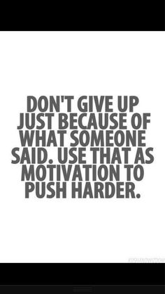


Pre-Game Planning

Academic Slam Dunk

Our teachers, administrators, community leaders, parents, and some of our students have worked together as a team on a game plan specifically for our school. That game plan is called our Alabama Continuous Improvement Plan (ACIP). The ACIP is our offensive game plan to score an academic slam dunk in reading and math. Our game plan also includes plays that will improve safety, achievement, attendance, attitude, and discipline, leading us to victory! The ACIP game plan will take us all year to play, but in the end we will have a blowout game!

The will to win is meaningless without the will to prepare.
Joe Gibbs

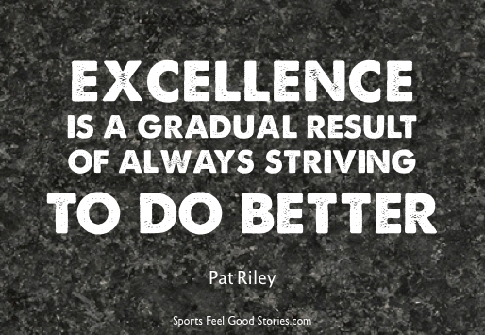

Clarke County High School

• Pre- Game Planning & Warm up
• Accountability Chalk Talk
• Practice Strategies
- Half Time
- Final Score

No Child Left Behind (NCLB) states that we must have a slam dunk in Reading, Math, and Attendance and/or Graduation Rate in order to win and have a successful year. Last year, we made progress with attendance and graduation and are going to try to keep it going.
Our school looks at data from the Scantron Performance Series, ACT, and Work Keys, as well as our Graduation Rate as our rule book to gauge academic success. This year our school’s current Graduation Rate is 95%.
Our school has identified areas of strengths and weaknesses from the Scantron Performance Series test that we will work on as a team to improve.

Page 1 CCHS 2017-2018

Accountability Chalk Talk



Our ACIP team looks at our game film (our test scores) each year and determines our strengths and weaknesses. Your teachers and administrators will be your coaches, and with your hard practice they will lead you to victory!
Reading Game Plan:
Longitudinal Data - Use current and ongoing data such as ninth and tenth-Scantron Assessment, eleventh-ACT and twelfth-Work Keys to identify the literacy standards of concern to drive instruction.

Math Game Plan:
Longitudinal Data - Use current and ongoing data such as ninth and tenth-Scantron Assessment, eleventh-ACT and twelfth-Work Keys to identify the math standards of concern to drive instruction.
Culture Game Plan:
Strategy One: (Student Mentoring) All students will be assigned an enrichment block in which the teacher will be a child advocate for his/her class.
Strategy Two: (Teacher Mentoring) Newly hired teachers will be assigned a master teacher.
Strategy Three: (Teacher Mentoring) Intervention – Students’ grades will be monitored to identify those who need additional assistance.
Strategy Four: (Student Attendance) Clarke County High School will follow the Clarke County Board of Education policy concerning truancy.
Strategy Five: (Teacher Attendance) Clarke County High School will follow the Clarke County Board of Education policy concerning attendance.
Strategy Five: (ACT Action Plan) Reading & Writing - Use online resources, practice tests, and test taking strategies to drive instruction. Mathematics - Use online resources, practice tests, and test taking strategies to drive instruction.
Strategy Six: (College and Career Readiness through Career Tech) CTE Enrollment - Enroll students in appropriate CTE classes - Students at Clarke County High School will be enrolled in appropriate Career Technical Education classes based on student requests, four-year plans, and course availability.

Work Hard, Play Hard


By half-time (mid-year) we will see how much progress we have made toward that big academic slam dunk. The only way we can stay in the game is if everyone on the team is working together for a win. Coaches will help those players who need more practice to pass the goal line and score!

Don’t let what you cannot do interfere with what you can do.


Final Score/ Coach’s Corner

Half-Time

Page 2

Setting a goal is not the main thing. It is deciding how you will go about achieving it and staying with that plan.
Tom Landry 

CCHS 2017-2018

-Dr. Ed Richardson, State Superintendent of Education

