Conecuh County Schools Virtual Parent Meeting
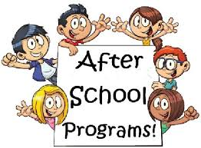
Who: K-3 Eligible Students and Parents
When: Wednesday, February 10, 2021 at 4:00 p.m.
Where : Virtual
How to join virtual: meet.google.com/hrv-iovx-pja
(Your child will receive a special invite through his/ her email)

Please contact your child’s reading specialist for more information:
School | Reading Specialist | Phone number
Conecuh County Jr. High / Repton Jr. High School | Mrs. Bree Riley | 251-966-5411 or 251-248-2960 or bree.simpson@conecuhk12.com
Evergreen Elementary School | Ms. Martha Campbell | 251-578-2576 or martha.campbell@conecuhk12.com
Lyeffion Jr. High School | Mrs. Amy Brock | 251-578-2800 or amy.brock@conecuhk12.com

