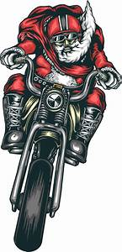
FIRST ANNUAL
TOY RIDE-IN
HALE COUNTY MIDDLE SCHOOL
120 WILDCAT WAY
MOUNDVILLE, ALABAMA 35474
Saturday, November 3, 2018

Drop Off Location: HCMS Parking Lot
8:00am-5:00pm

50\50 Drawing
Food
Fun
Fellowship

Help us this Holiday Season bring smiles to children in our community. Donate a new unwrapped toy for a child.

Sponsors
Greater Miracle House of Prayer Outreach Ministry
(Pastor’s Aid Department)
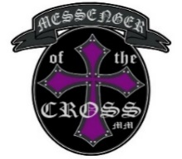
Pastor: Bishop Dennis J. & Elect Lady Edith McCarter

Messenger of the Cross MM, Hale County Chapter
Mrs. Tracey Hunt, National Secretary

All Churches, Groups, Organizations, Clubs and Businesses are welcome to participate.
For more information contact Mrs. Tracey Hunt @205-614-7051 or Mrs. Carla Green @ 334-507-3990

