HES Board Walk
Annual HES
Walk-a-thon
Sponsored by Headland Elementary School
~ Due November 1 ~

EVENT SPONSOR FORM
Company Name:_______________________________________________________________
Contact Name:_________________________________________________________________
Phone:_______________________________________________________________________
Mailing Address:_______________________________________________________________
Email Address:_________________________________________________________________
Sponsor in the name of:_________________________________________________________

Headland Elementary School will host a Walk-a-thon on November 9th for the one and only school sponsored fund raiser. The theme will be HES Board Walk. The funds raised will be used to purchase supplies and materials to support student learning, and the arts. In addition, technology will be purchased for the classrooms. We are requesting support from our community stakeholders to help make this event a success. We need support to purchase prizes for students to encourage them to get sponsors. A donation in any amount would be greatly appreciated. All donations of $100 or more will be advertised on a banner that will hang in the school for the year. Above, you will find a sponsorship form. Please indicate the student(s), if any, you would like to receive credit for your donation. Thank you for supporting the future leaders in Headland, Alabama.
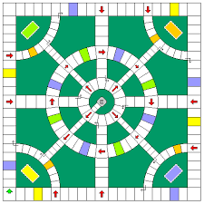

For more information, please contact Carmen Neiswanger at cneiswanger@henrycountyboe.org or 334-726-6309.
Please make checks payable to Headland Elementary School 305 Mitchell Street, Headland, AL 36345

