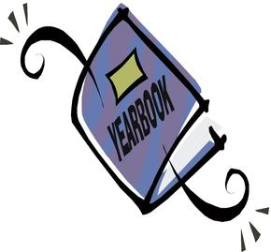
It’s Yearbook Time!

What:
- 2018-2019 Yearbook on sale
- 64 pages of full color featuring all the students and staff.
- Limited number of books available.
When:
- January 22nd – February 8th
- $30 per book
- Make checks payable to HES. Please include your driver license number and date of birth.

Student Name _____________________________
Homeroom Teacher________________________
Payment___________________________________

