- Go to Blackboard @ https://pcsd-k12.blackboard.com.
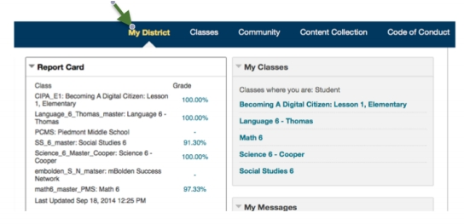
- Login to Blackboard with your child’s S number and password.
- Select the District Tab as shown below:

- From this tab, you will see the District Report Card where his/her teachers post your child’s grades for each class.
- In order to see the individual grades for each class in the list, select one of the grades on the report card as shown below.

Please email or call any of your child’s teachers if you have any questions or concerns. Our number one goal is to provide the best education possible for all of our students.
