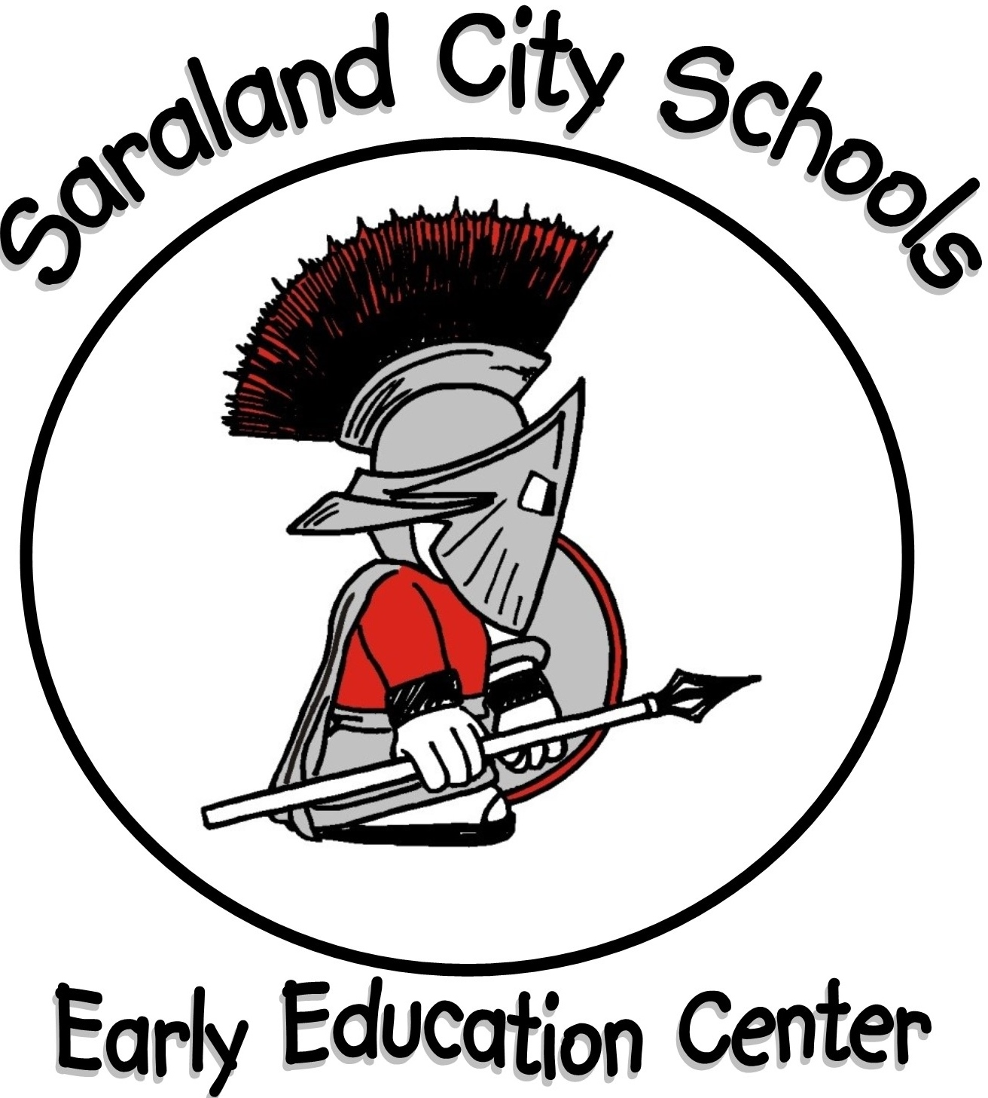

**Saraland Early Education Center**

**2019-2020**

**First Grade Supply List**

* 1 - 1” white binder with a clear cover
* 1 - plastic pencil box
* 2 - dozen sharpened #2 pencils
* 4 - boxes 24-count Crayola crayons
* 2 - packs fat washable markers
* 1 - pair blunt tip Fiskars scissors
* 2 - boxes standard pencil erasers
* 2 - bottles Elmer’s 4 oz. white glue
* 4 - Elmer’s glue sticks
* 1 - highlighter
* 1 - plastic folder with prongs & pockets
* 1 - pack fat Expo dry erase markers
* 2 - *Mead* K-2 Primary Journals-

Creative Story Tablet (red & blue lined)

* No rolling book bags

**Kindergarten Supply List**

* 1 - 1” white binder with a clear cover
* 1 - plastic pencil box
* 4 - boxes 24-count Crayola crayons
* 1 - pack fat washable markers
* 1 - pair blunt tip Fiskars scissors
* 3 - 10 pack sharpened pencils
* 2 - large fat erasers
* 2 - bottles Elmer’s 4 oz. white glue
* 4 - Elmer’s glue sticks
* 1 - eight-color watercolor paints
* 1 - plastic folder with prongs & pockets
* 1 - pack Play-Doh brand playdoh
* 1 - pack Expo dry erase markers
* 2 - *Mead* K-2 Primary Journals-

Creative Story Tablet (red & blue lined)

* 1 - pencil pouch
* No rolling book bags

**Uniform (Other)**

* + Solid red, black, or gray jacket (no hoodies)
  + Black belt
  + White socks
  + **Black rubber-soled shoes

(white trim only – no other colors)

* + Black/white saddle oxfords

** Velcro shoes are strongly suggested for students

unable to tie their own shoes.

**Uniform Bottoms**

* + Khaki shorts (knee length)
  + Khaki pants
  + Khaki skorts (no khaki jumpers)
  + Saraland plaid skirt/skort
  + Saraland plaid jumper

**Uniform Tops**

* + Solid red polo (includes pre-k)
  + Spartan Spirit Shirt (Fridays only)
  + Spartan sweatshirts (no hoodies)
  + White Peter Pan shirt

(only with Saraland plaid jumper)