WHO: SMS 7th and 8th graders
WHAT: the ultimate field trip
WHEN: May 4-10, 2019
WHERE: Charlottesville, Gettysburg, Philadelphia, and New York City

The trip features the following highlights:
Monticello, the home of Thomas Jefferson * ghost tour in Gettysburg * Gettysburg Battlefield tour * the Liberty Bell * Independence Hall * city tour of NYC * Central Park * the 9/11 Memorial & Museum* shopping * the Empire State Building * the Statue of Liberty * Ellis Island * a Broadway show * a full free day in NYC

COST:
The price of the trip is based on the number of occupants per bus. That number is determined by the number of participants and the number of buses required. The exact price is determined when we know exactly how many people are going. It will be no lower or higher than the prices listed below:

Quad Room: $940 to $970 per person
Triple Room: $1005 to $1035 per person
Double Room: $1065 to $1095 per person

The price of the trip includes the following:
*13 meals
*all lodging
*deluxe motor coach transportation
*all tour and admission fees which are part of the trip

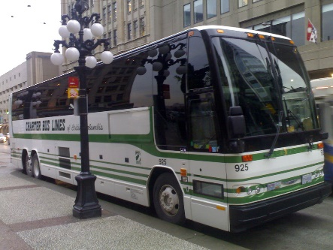

PAYMENT DEADLINES:
There are three payment deadlines that must be observed. They are as follows:

*October 12: $100 per person to reserve your spot
*January 11: ½ of your balance
*March 22: remaining balance

VERY IMPORTANT:
Every student on the trip must have an adult along who assumes responsibility for the student. If your parent is not going, it is up to your family to locate someone who is willing to be responsible for you and allow you to stay in his or her room. Though we will try to help, the school is not responsible for finding you a roommate and chaperone.

To reserve your spot on the trip, return the attached reservation sheet, along with $100 per person, to Mrs. Preston by
October 12, 2018. Make checks payable to SMS.
More information can be found at sms.sccboe.org. If you have additional questions, you may also contact Coach Freed, Mrs. Gravlee, or Mrs. Preston via the website.

Facebook Page: SMS NY trip 2019
Sign up for Remind by texting @smsnyt to the number 81010

To reserve your spot on the trip, return this form, along with a $100 per person deposit, to Mrs. Preston. Deadline for deposit: October 12th.
Make checks payable to SMS.
Name of student: ____________________________________ Homeroom Teacher________
Name of adult(s) accompanying student: __________________________________________
If a family member is not accompanying the student, who will be supervising the student?
_____________________________________________________________________________
Family email address: __________________________________________________________
Phone number: __________________
What type room do you anticipate needing?
________DOUBLE (two people in your room = highest priced option)
________TRIPLE (three people in your room = mid-price option)
________QUAD (four people in your room = lowest priced option)
If you plan to share a room with another party, please list those names here:
_____________________________________________________________________________
(If you are still working out the details, it is fine. We just need to know on or before the January payment deadline.)
Name and T-shirt size of each person in your party:
_____________________________________
_____________________________________
_____________________________________
_____________________________________

If you have questions, you may contact Coach Freed, Mrs. Gravlee, or Mrs. Preston through the school’s website at sms.sccboe.org.

