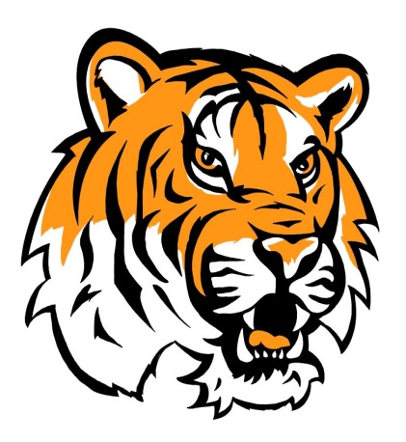
HOODIES ARE BACK BY POPULAR DEMAND!
We have Shasta Meadows “hoodies” for sale once again. We will be placing a ONE-TIME order on September 1, 2017. We do not have sample sizes of sweatshirts at this time. Sizes typically are as follows SM 8-10, Med 10-12, Lg 12-14 and XL 14-16 children’s.
Adults would be SM, Med, Large and XL.
Please complete and return the order form with payment.
**please allow a few weeks for orders to be filled and delivered to the classrooms

Shasta Meadows Hoodies (Navy only)
Pre-Order Forms Due Sept 1st (NO LATE ORDERS ACCEPTED)

Student Name ________________________________ Room #__________

Youth (Sm, Med, Lg, XL) $25.00 x _______ = $________ Size ________

Adult (Sm, Med, Lg, XL) $25.00 x _______ = $________ Size ________

Adult (XXLG or XXXLG) $30.00 x _______ = $________

Total Order $__________

Shasta Meadows T-Shirts

Student Name ________________________________ Room #__________

Youth (Sm, Med, Lg, XL) $10.00 x ______ = $________ Size ________

Adult (Sm, Med, Lg, XL) $12.00 x ______ = $________ Size ________

Adult (XXLG or XXXLG) $15.00 x _______ = $________

Total Order $__________

Shasta Meadows Sports Bags
Student Name _______________________________ Room # _________
Shasta Meadows Tote (one size, sample in office) $3.00 x _____ = $ ________
Lanyard (Sample in office) $1.00 x _____ = $ ________

Office Use Only: Cash/Check#__________________________ Date: _____________ By: ______________

