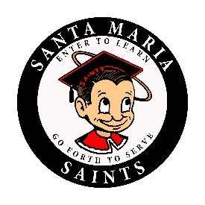
SANTA MARIA HIGH SCHOOL
DAILY BULLETIN
Friday, August 31, 2018

GENERAL

CLUBS

- Its minimum day today and we are having our first movie day at Las Comadres Club in room 221 at 1:00 P.M. see you there!

- CSF meeting TODAY after school 3:00 p.m. in room 620.

SPORTS

- Attention all girls interested in playing girls basketball, workouts for all levels will be held Monday thru Thursday from 5:00 p.m. to 6:30 p.m. in Wilson Gym. You need to have your athletic physical completed to be eligible! Wear basketball clothes & shoes to the workout. If you have any questions, please see Coach Jimmy afterschool in the Gym.

Santa Maria High School - Go, Saints!

