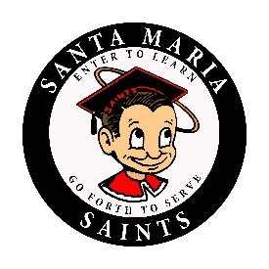
SANTA MARIA HIGH SCHOOL
DAILY BULLETIN
Monday, June 4, 2018

GENERAL

- Senior SHIRTS still available...If you DID not purchase a SANTA MARIA HIGH SENIOR SHIRT or Sweatshirt, Stop by ROOM 230, there are a few left for only $20.

- Attention OTCR Students: Please report to room 235 at Lunch or After School on a daily basis until you have completed all of your OTCR courses. Failure to do so may affect your Graduation status.

- If you lost an earring or a ring at Prom, please see Mrs. Draper in room 233 to claim it.

- Attention seniors: Do you need a job for this summer? There will be two agencies who have immediate positions available for you to work. If you are interested in working during the summer, stop by the career center and also the conference room located in the library TODAY after school at 2:15 P.M. If you have any questions please see the Community Liaison (Patty Lopez) or Miss Washington in the career center.

- Attention seniors, if you attended Senior Honors Night and was given an incorrect certificate, please bring the certificate to Ms. Washington to receive a new certificate.

- If you took the Chicano/Latino Studies class and are graduating this year, please see Mr. Valencia in room 615 to pick up your graduation sash.

CLUBS

- Attention all Saints, AP Promoters has started planning for next semester's March of the Saints. In order for this event to be a success, all coaches and club advisers need to request special events forms from Mr. Orlick in room 632. These will be distributed as soon as possible, so please contact AP Promoters before the school year is over. AP Promoters thanks all staff for the continued support.

SPORTS

Last Day of School: Wednesday, June 6th

Congratulations Class of 2018 – Thursday, June 7th

Santa Maria High School - Go, Saints!

