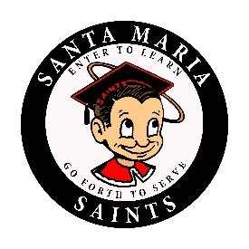
SANTA MARIA HIGH SCHOOL
DAILY BULLETIN
Monday, September 10, 2018

GENERAL

- The California Scholarship Federation application is now available! Have you been academically excellent with A's and B's from last semester? Apply to be a CSF member so that you can be on track to earn a special cord, pin, and gold seal on your diploma! Applications can be picked up from any one of the CSF officers and make sure to follow us CSF on instagram at CSFsmhs to get new updates. Applications are due September 21st to a CSF officer.

- Juniors and seniors, listen up, are you interested in being a part of the homecoming court? Juniors we are looking for a Prince and a Princess, seniors for a King and a Queen. Come to an informational meeting TODAY at lunch, room 609–don’t miss out!

- Picture Re-takes: Any student or staff that has not taken a picture for the yearbook can take their picture on make-up day TODAY ONY from 8:30 p.m. – 3:00 p.m. in Ethel Pope.

CLUBS

- The Close Up Washington DC, Club will meet TODAY at lunch in Mrs. Henning’s room to distribute paperwork for our current fundraiser.

- The Alpine Club will meet at lunch on Tuesday in room 640.

- The KPop Dance Club will be meeting on Tuesday after school at 3:05 p.m. in Ms. Toews' room (623).

- Do you like math and science? Want to work with Engineers from Cal Poly? Join the Society of Hispanic Professional Engineers (SHPE). We will be having our first informational meeting on Tuesday, September 11th at lunch at room 360 in Ms. Eppley's room. Come to learn more information about what our club is about and how you can get involved with other students!

SPORTS

Santa Maria High School - Go, Saints!

