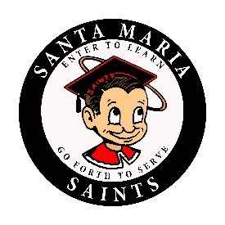
SANTA MARIA HIGH SCHOOL
DAILY BULLETIN
Thursday, September 20, 2018

GENERAL

- Hey Saints! Have you turned in a new LUNCH application this school year? If NOT, You might be eating free right now, but without a new application you will be dropped from the program. Last day to eat free is Monday, September 24, 2018. Turn in your lunch application today or (apply online for a 1 day process at family.titank12.com). See the Community Liaison-Patty Lopez Barriga in room 124 next to the attendance if you have any questions.

- Seniors, make sure to show up to your 6th period class TODAY. After roll is taken, the teacher will dismiss you so you can attend the senior class meeting in Ethel Pope Auditorium.

- Are you going to the homecoming dance? If so, pickup your dance form from the business office today! ALL students, must return the form to the business office. Don’t procrastinate!

- Hey seniors, if you have ideas for the homecoming skit or are interested in having a part in the skit, please come to the senior class meeting at lunch on Monday, September 24th in Mrs. Draper's room 233!

CLUBS

- Alpine club students planning to go to Valencia Peak, remember to turn in your medical forms TODAY to Mrs. Henning’s, room 640.

- Attention all Spanish Honor Society members there is a meeting TODAY during lunch. Please be on time, we need to finalize our sale for Friday’s Fair.

- Attention all Students, Spanish Honors Society is selling Tostilocos at the Fall Fair this Friday. Bring $4 if you would like to buy one!

- Society of Hispanic Professional Engineers (SHPE) will be having the next meeting on September 25th at lunch in Ms. Eppley's, room 360. Please turn in your Activity waiver, signed by your parent at this meeting so that you may participate in afterschool events.

Santa Maria High School - Go, Saints!

