auto0Arriba-Flagler CSD 20

FLAGLER PUBLIC SCHOOLS

**Tom Arensdorf – Superintendent of Schools** tarensdorf@af20.net

P.O. Box 353, Flagler, CO 80815 719-765-4684 ext. 223

April 1, 2015

Dear Arriba-Flagler CSD #20 Community,

Each year, school districts in Colorado are required to report school performance to the community, as required by No Child Left Behind. Because this required information is available on the Colorado Department of Education’s website, districts are no longer required to produce an individual annual report to the public.

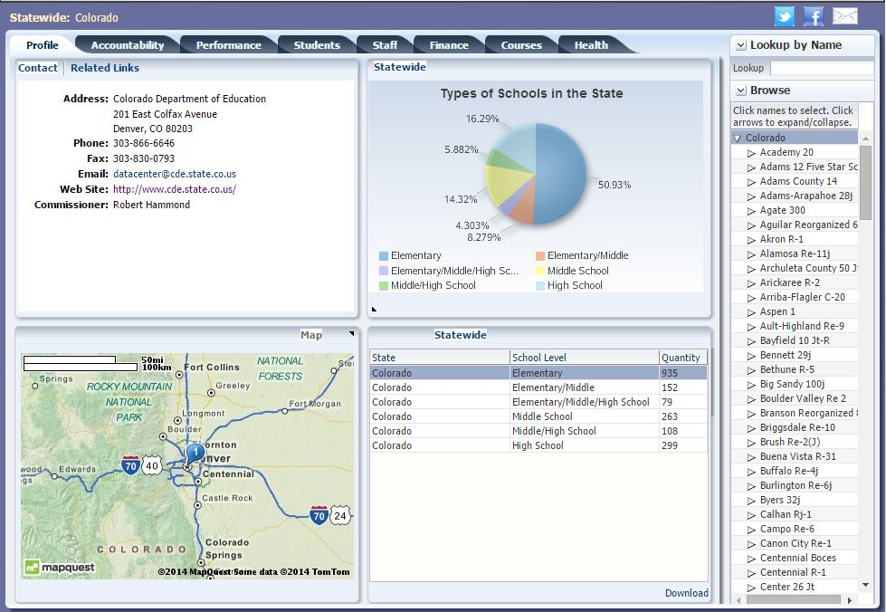Instructions on accessing school and district performance are available below. If you do not have access to the Internet or would prefer to receive a hard copy of this information from the district, contact Tom Arensdorf at 719-765-4684 or by mail at P.O. Box 218, Flagler, CO 80815 A paper version will be mailed to you or be available for pickup.

Access School/District Performance Information

* **Visit** the SchoolView Data Center at: <http://bit.ly/1zE9ogA>. School districts are listed on the right side of the page, in alphabetical order.
* **Click** the arrow below the district name to display schools in a district. Tabs across the top of the page assist users in navigating through the different data sets.
  + The **Performance** tab contains state test (TCAP) results by grade, school, district and the state.
  + The **Accountability** tab contains School and District Performance Frameworks (SPF/DPF), federal data requirements (Title I Annual Measureable Objectives and Title III Annual Measureable Achievement Objectives).
  + The **Staff** tab contains the number of highly qualified teachers in a school or district, as well as teacher equity, which ensures that poor and minority students are not taught by inexperienced, unqualified, or out-of-field teachers at higher rates than their white or more affluent peers.

**Sample Screen Shot of the SchoolView Data Center**

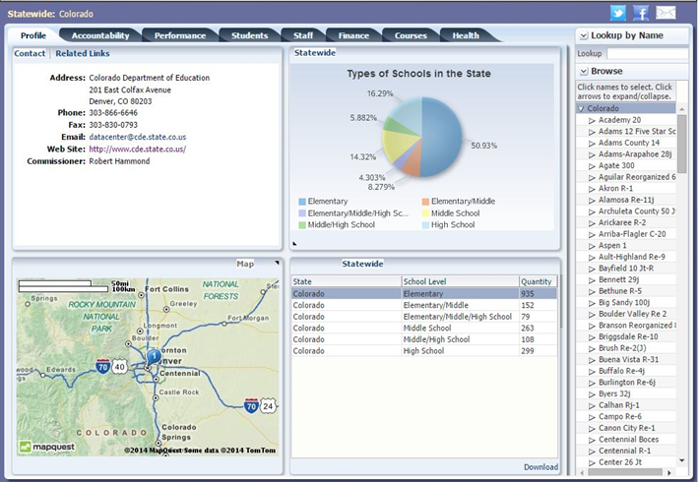

Thomas M. Arensdorf

Superintendent of Schools

Arriba-Flagler CSD #20