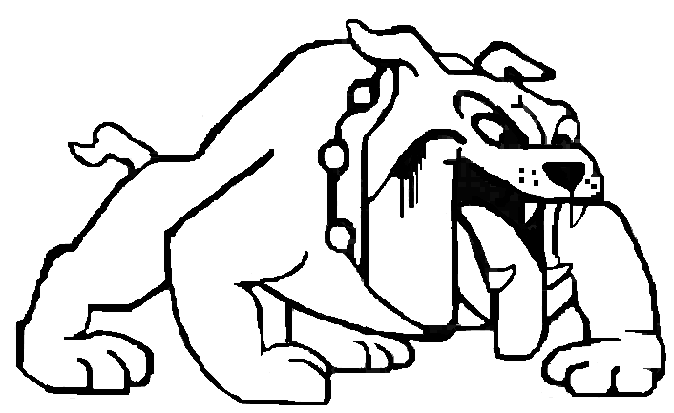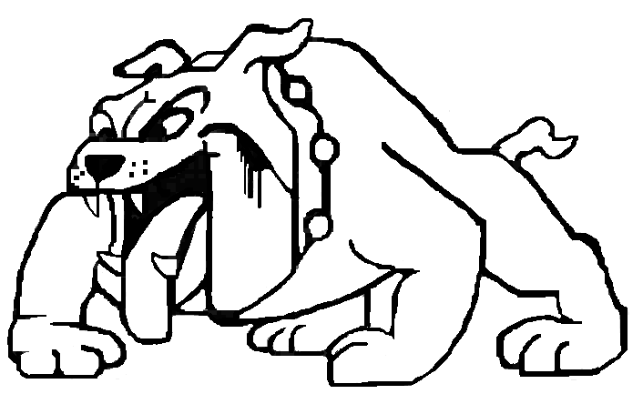
Stephen Pitts
Assistant Principal

Stephen Pitts
Principal
Zola Akins
Assistant Principal

School Supply List 2017-2018
Kindergarten  - #2 wood pencils (12 count)  - 3 packs of Elmer’s Washable Glue Stick  - 1 pair of Fiskars blunt scissors  - 1 box of Kleenex  - 1 box (24) Crayola Crayons  - 1 Bottle of Hand Sanitizer  - 1 container of sanitizing wipes  - 1 manuscript writing pad  - 1 folder with prongs and pockets (for homework)  - 1 crayon/pencil box  - Raincoat to keep in classroom or book bag | First  - 1 box (24) crayons  - 1 Scissors (blunt end)  - 2 boxes Kleenex  - 4 glue sticks  - 2 boxes of #2 pencils (12 count)  - 2 bottles of Hand Sanitizer  - 1 supply box  - 4 packages of Notebook paper (wide ruled)  - 1 container Clorox wipes  - 1 pack of copy paper
Second Grade  - 1centimeters and inches ruler  - 2-1 Subject Notebook 200 pages  - 3 Hard Covered Marble Composition Notebooks  - 2 Pack of Loose Leaf Notebook Paper (wide ruled)  - 1 ream of white copy paper  - 4 pocket folders with Prongs  - 2 boxes of 24 Crayola crayons  - 2 dozen #2 sharpened pencils  - 2 pink erasers  - 2 large glue sticks  - 1 pair of scissors  - 2 colored red pens  - 1 highlighter  - 2 packages of Dry Erase Black Markers (1 chisel tip and 1 fine tip)  - 2 Black Sharpies Fine Point  - 1 box of tissues  - 1 bottle of hand sanitizer  - 1 container of Clorox/Lysol wipes  - Boys: 1 Ziploc gallon bags  - Girls: 1 Ziploc sandwich bags  Donations (not required, but greatly appreciated):  Extra tissues  Extra disinfecting wipes  Extra hand sanitizer | Third Grade  - 2 boxes of Kleenex  - 1 bottle of hand sanitizer  - 1 box of Clorox wipes  - 3 packs of wide rule paper  - 3 boxes of #2 pencils (12pk or more)  - Erasers- block or pencil toppers  - 1 three-ring binder (one inch with clear view cover)  - Pencil Pouch (with 3 holes for binder)  - 1 package of dry erase markers

559 Greensboro Highway
Quincy, FL 32351
Phone 850 442-6327
Fax 850 442- 952

Uniform Schedule

Monday | Hunter Green polo Shirts with Khaki Bottoms
Tuesday | Gold shirts with Black Bottoms
Wednesday | Black polo Shirts with Khaki Bottoms
Thursday | Green and Gold Day  Green or Gold polo shirts with Black Bottoms
Friday | Bottom choices  - Denim (Jean Bottoms)  - Black Bottoms  - Khaki (tan) Bottoms  Top choices  - Spirit Shirt or Black Polo

District Uniform Policy

1. All students in elementary or middle school shall wear a school uniform while in attendance during the regular school day and on sponsored field trips.
2. Colors shall be that of the official school colors and other colors as recommended by the School Advisory Committee and approved by the principal of the school.
3. Shirts/blouses must have a collar. T-shirts may be worn at the discretion of the individual school. Shirts 0must be tucked into Pants.
4. Uniform style bottoms will be dark blue, black, tan (khaki). No sweat pants, overalls, or jeans will be allowed.
5. The legs of pants shall not extend below the heels of the shoes.
6. Uniform knee-length shorts/ skins will be acceptable.
7. Sneakers and leather shoes are both acceptable, but must be black, dark brown, dark blue or white with matching shoelaces.
8. Socks must be black, white or other color as approved by the principal.
9. Boys and girls must wear a belt if pants/shorts have belt loops. NO sagging pants will be allowed.
10. Outer garments for cold weather are permissible.

