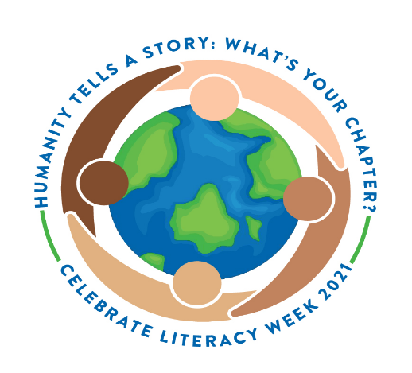
Literacy Week
Activities
Theme: HUMANITY TELLS A STORY: WHAT’S YOUR CHAPTER?
Monday, January 25nd | Million Minute Marathon:  Students and staff will drop everything and read for 20 minutes of silent sustained reading to help contribute to the marathon. Start time 9:00 a.m.
Tuesday, January 26th | Hat Day:  Students will be allowed to wear their favorite hat to school.
Wednesday, January 27th | Character Dress Up Day:  Students and staff are encouraged to dress as characters from their favorite books.
Thursday, January 28th | Wear RED . . . Be Well READ!  Students, faculty and staff are asked to wear red in honor of being “Well Read.”  Teachers will read their favorite book to the class.
Friday, January 29th | Culminating Activity: Humanity Tells a Story.  Students will write an autobiography or poem about themselves to tell the next chapter in their life.

