Gadsden County School District

[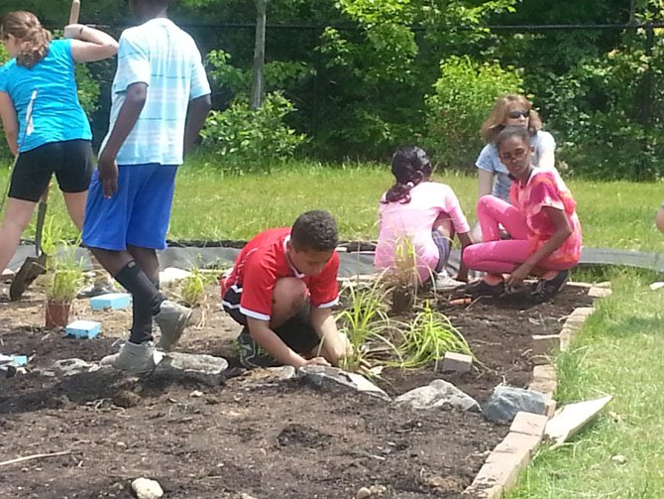](http://www.google.com/url?sa=i&rct=j&q=&esrc=s&frm=1&source=images&cd=&cad=rja&uact=8&ved=0CAcQjRxqFQoTCNSXp9rT_8gCFUZ0PgodqpMF8g&url=http://www.connectionnewspapers.com/photos/galleries/2013/jul/24/learning-doing/&psig=AFQjCNEtEoIVKBGXqzMAVdMJcSBu6iG02w&ust=1447031743992668)

for more information contact:

Dionne Nelloms/District Curriculum Coordinator

Sara Knight/District Reading Coordinator

Betty james/ PreK-5 ETO Specialist

Doris Hinson/6-12 ETO Reading Specialist

Calvin Trombley/Science Specialist K-12

 850-627-9651

Project-Based Learning Experience

STEWART STREET ELEMENTARY

Wednesday

November 18, 2015

Time: 10a.m. -12 noon

A Learning-By-Doing Experience!

Projects-Based Learning is based on Journeys and Collections Reading Programs learning experiences.

