**Broxton-Mary Hayes Elementary School**

***Parent and Family Engagement Policy and Plan for Shared Student Success***



*2017–2018 School Year*

*Broxton-Mary Hayes Elementary School*

*Mrs. Allyson Speight, Principal*

*410 South Alabama Street*

*Broxton, GA 31519*

*(912) 359-2391*

*http://broxtonmaryhayeselem.ga.cce.schoolinsites.com*

*Plan Revised June 30, 2017*

**What is Title I?**

Broxton-Mary Hayes Elementary is identified as a Title I school as part of the Every Student Succeeds Act (ESSA). Title I is designed to support State and local school reform efforts tied to the challenging State academic standards to improve teaching and learning for students. Title I programs must be based on effective means of improving student achievement and include strategies to support family engagement. All Title I schools must jointly develop with parents and family members a written parent and family engagement policy.



School Plan for Shared Student Achievement

**What is it?**

This is a plan that describes how Broxton-Mary Hayes Elementary will provide opportunities to improve family engagement to support student learning. Broxton-Mary Hayes Elementary values the contributions and involvement of parents and family members to establish an equal partnership for the common goal of improving student achievement. This plan describes the different ways that Broxton-Mary Hayes Elementary will support family engagement and how parents can help plan and participate in activities and events to promote student learning at school and at home.

**How is it revised?**

Broxton-Mary Hayes Elementary School invited all parents to attend our annual School Forum last spring to review and revise this parent and family engagement policy, as well as the schoolwide plan, our school-parent compact, and the family engagement budget. Broxton-Mary Hayes Elementary School establishes a Parent Advisory Committee to help provide suggestions, recommendations, and advisement on all matters related to parent and family engagement. Additionally, parent input and comments regarding this plan are welcome during the school year through an online form. The plan is posted on our school website for parents to view and submit feedback throughout the year. All parent feedback received during the year will be used to revise the plan for the next school year. We also distribute an annual survey online to ask parents for their suggestions on the plan and the use of funds for family engagement. Parents and family members can also give feedback during several parent meetings and activities during the school year.

**Who is it for?**

All students participating in the Title I, Part A program, and their families are encouraged and invited to fully participate in the opportunities described in this plan. Broxton-Mary Hayes Elementary will provide full opportunity for the participation of parents and family members with

Limited English Proficiency (LEP), parents with disabilities, and those of migratory children. Migrant staff is utilized to the extent possible to communicate information related to school and parent programs/activities in the language used in homes of participating children.

**Where is it available?**

At the beginning of the year, the plan is distributed at the Annual Title I Parent Meeting. Paper copies are sent home with students, displayed in the Parent Resource Center, Media Center, and Office. Parents can also retrieve a copy of the plan from these various locations. An electronic copy is also located on the school website at <http://broxtonmaryhayeselem.ga.cce.schoolinsites.com>.





School-Parent Compacts

As part of this plan, Broxton-Mary Hayes Elementary stakeholders including and our families jointly developed a school-parent compact, which is an agreement between parents, teachers, and students. The compact explains how parents and teachers will work together to make sure all our students reach grade-level standards. The compacts will be reviewed and updated annually based on feedback from parents, students, and teachers during the annual revisions meeting in the spring. The school-parent compacts are also shared with parents during parent-teacher conferences and kept with each child’s teacher if parents need another copy.

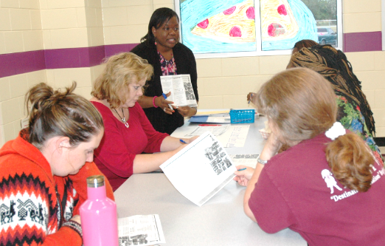

2017–18 District Goals

* The Coffee County School System will increase the percentage of students scoring at the Developing level or above in English Language Arts on the Georgia Milestones End of Grade (EOG) Assessment.
* The Coffee County School System will increase the percentage of students scoring at the Developing level or above in Mathematics on the Georgia Milestones End of Grade (EOG) Assessment.

2017–18 School Goals

* Broxton-Mary Hayes Elementary will increase by 3% the number of students performing at or above proficiency in Language Arts in Grades 3-6 as measured by Georgia Milestone Assessment System.
* Broxton-Mary Hayes Elementary will increase the number of students performing at Level 3 or 4 on the Narrative Writing Response in Grades 3-6 on the Georgia Milestone Assessment System.

**Let’s Get Together!**

Broxton-Mary Hayes Elementary will host the following events to build the capacity for strong family

engagement to support a partnership among the school, parents, and the community to improve student

academic achievement according to the Georgia Standards of Excellence. Parents, family, and

community members are invited to attend all school events.

Open House – August 10, 2017 (4:00 - 6:00 PM)

Meet your child’s teacher and our friendly and helpful school staff for the year.

Annual Title I Meeting – August 24, 2017 (6:00 - 6:30 PM)

We invite you to an evening of learning and sharing about our Title I program, including our parent and family engagement policy, the schoolwide plan, the school-parent compacts, and parents’ requirements. Invitations will be posted in the school newsletter, social media, and local media.

Back to School Safari/PBIS/Test Taking Skills – August 24, 2017 (7:00 - 8:00 PM)

Receive information on how to help your child do well throughout the school year.

BEST Kid Assembly – Monthly (9:00 AM or 1:00 PM refer to school flyers and newsletters)

A celebration and recognition of your child’s success

Parent/Teacher/Student Conferences – September 14, 2017 & February 8, 2018 (10:00 - 6:00 PM)

Scheduled updates on your child’s progress.

Character Building/Bullying/PBIS Celebrations Family Night – October 5, 2017 (6:00 - 7:00 PM)

A celebration of PBIS and the recognition of its impact on school and student success

Receive tips on character building and bullying.

Thanksgiving Lunch – November 16, 2017

Parents, students, staff, and community members will fellowship and enjoy a Thanksgiving meal.

Reading Around the Christmas Tree Family Night – December 14, 2017 (6:00 - 7:00 PM)

Enjoy a night reading, drinking hot cocoa, pictures with Santa, learning about Reading Counts and Lexile Levels.

Annual School Wide Christmas Program – December 19, 2017 (6:00 - 8:00 PM)

Enjoy a night of Christmas music and skits performed by our students and staff.

Math Carnival Family Night – January 25, 2018 (6:00 - 7:00 PM)

Enjoy fun games learning math, state standards, and the importance of math fact fluency and problem solving.

Career Day – February 2, 2018

Students dress up and share what they would like to be during our Career Day Program.

Family Write Night – March 15, 2018 (6:00 - 7:00 PM)

Parents will enjoy student writing, receive requirements and tips on how to help their child with writing at home.

School Forum/Title 1 Documents Revision Meeting – May 10, 2018

A forum for parents and family members to participate in roundtable discussions with the principal and staff regarding the schoolwide plan, parent and family engagement policy, school-parent compacts, and the family engagement budget. Connect with the school and community to build a better school and review school plans.

***Honors Programs- May 21, 2018 & May 22, 2018***

**1st & 2nd 8:30 - 9:30 AM & 3rd, 4th, 6th 10:00 - 11:00 AM**

**Kindergarten Graduation 8:30 AM**

**Pre-K Honors Assembly 10:00 AM**

**5th Grade Crossover 6:00 PM**

Broxton-Mary Hayes Elementary is committed to helping our parents and families with flexible scheduling attend the family activities as well as parent meetings listed in this policy. Please contact the school if you need assistance with child care or transportation in order to participate in our programs.

Parent and Family Engagement

Broxton-Mary Hayes Elementary believes that family engagement means the participation of parents and family members in regular two-way and meaningful communication involving student academic learning and other school activities, including ensuring:

* Parents play an integral role by monitoring their child’s progress and working with educators to improve their child’s performance.
* Parents are encouraged to be actively involved in their child’s education at school.
* Parents are full partners in their child’s education and are included, as appropriate, in decision-making and on advisory committees to assist in the education of their child.
* The carrying out of other activities as described in this plan.

**Broxton-Mary Hayes Parent Resource Center**

Come visit our Parent Resource Center located in Room 402 to check out educational resources; which includes books, study materials, and activities to use at home with your child. Parent Portal information is also available. For more information, visit our school website or contact Mrs. Yolanda Daniels, Parent Engagement Coordinator at 912-359-2391 ext. 6872

**Broxton-Mary Hayes Elementary is Branching Out!**

Broxton-Mary Hayes Elementary will take the following measures to promote and support parents and family members as an important foundation of the school. In order to further strengthen and build parent’s capacity through school wide initiatives, communications, and resources to reach our school goals, we will:

* Ensure that all information related to school and parent programs, meetings, and other activities is published in both English and Spanish, posted on the school website, school marquee, school-based social media, and included in the monthly school newsletter for all families
* Provide monthly trainings for staff during their planning periods on strategies to improve communication with parents and ideas to increase family engagement with reading, writing, math, science, and social studies activities for our students outside of the classroom.
* Partner with early childhood programs and provide resources; such as a parent resource center, that encourages and supports parent participation in the education of their children to prepare them for college, career, and life.
* Provide assistance to parents in understanding the school’s academic standards and assessments as well as the ways parents can monitor their child’s progress and work with educators.
* Communicate with all families and the community on a regular basis regarding schoolwide events and activities, through phone messages, social media, and flyers.
* Work with our parents to develop relevant trainings and helpful presentations to educate our staff on the importance of parent and family engagement and how to support student learning.
* Provide necessary materials and handouts for parents at conferences, meetings, family nights, and activities to help parents work with their child to improve their child’s achievement.
* Develop appropriate roles for community-based organizations and businesses in parent and family engagement activities.

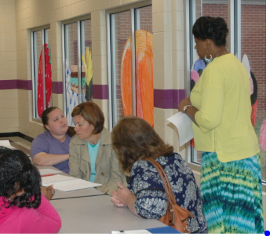 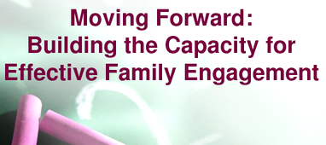 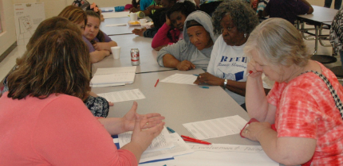

**School-Parent-Community Outreach** 

* Yes, I am interested and wish to join the School-Parent-Community Outreach.
* Please contact me so I can learn more in joining.
* Please contact me about volunteering if help is needed.

Name:

Child’s Name and Grade:

Address:

Phone Number:

Email address:

Parent and Family Engagement Standards

Broxton-Mary Hayes Elementary and our parents have adopted the National PTA Standards for Family-School Partnerships as the school’s model in engaging parents, students, and the community. These standards are:

1. Welcoming All Families
2. Communicating Effectively
3. Supporting Student Success
4. Speaking Up for Every Child
5. Sharing Power
6. Collaborating with Community

School-Parent-Community Outreach

Broxton-Mary Hayes Elementary invites all parents to join the School-Parent-Community Outreach to volunteer within our school, share ideas and ways to involve other parents and family members to build partnerships with school, families, and the community. You will be able to submit your ideas or suggestions at school activities, meetings, as well as through our parent surveys and website. If you would like to learn more about the School-Parent-Community Outreach, please contact the principal at (912) 359-2391 or complete the interest form and leave it in the Main Office.

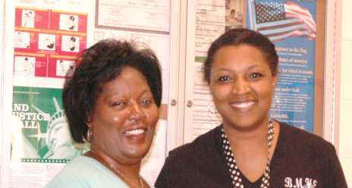

**Share Your Thoughts** 

We want to hear from you. If you have any suggestions or if there is any part of this policy that you feel is not satisfactory with the students’ and the school’s goals for academic achievement, please provide us with your comments in the space provided and leave this form in the Main Office:

Name: (optional)

Telephone Number: (optional)

_____________________________________________________________________