Senior Ads for the 2018 Yearbook

Quarter page only ads - $50.00

Ads can contain text and images/pictures
Please email images to kbriggs@hackettcp.org - no pdfs please. Send this form with a check made out to Hackett to the office by January 31st, 2018.

Indicate example style SL_________

Space is limited so please get them in as soon as you can.

We can also do only one picture.

Please make sure any images are not protected under copyright. We will not be allowed to include those.
Examples of ads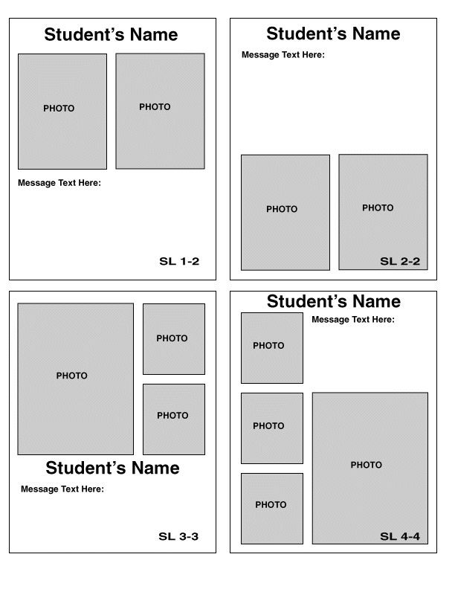
Message: Please keep to under 100 characters due to space constraints
Name of student:
Who the ad is from:

