

Calhoun R-VIII

Newsletter

Lindsay Rusche is a senior who enjoys school and extracurricular alike. If she isn’t studying or reading, she is hanging out with friends, playing volleyball, or watching *Bates Motel*, *Cupcake Wars*, or the ID Channel.

**Important Dates:**

Dec 1 – ASVAB testing

Dec 2 – CSA Adult Co-ed Volleyball Tournament

Dec 4-9 – Tiger Classic @ Kingsville

Dec 5 – Title I and SAC Family Night @ 5:30

Dec 12-Jan 16 – BOE Candidate Filings

Dec 12 – Christmas Concert and Art Show @ 6:00 pm

Dec 13 – ECC Winter Family Night @ 6:00 pm

Dec 18 – BOE Meeting @ 6:00 pm (HS Computer Lab)

Dec 19 – k-12 Early Release @ 12:30 pm

Dec 20-Jan 3 – Christmas break

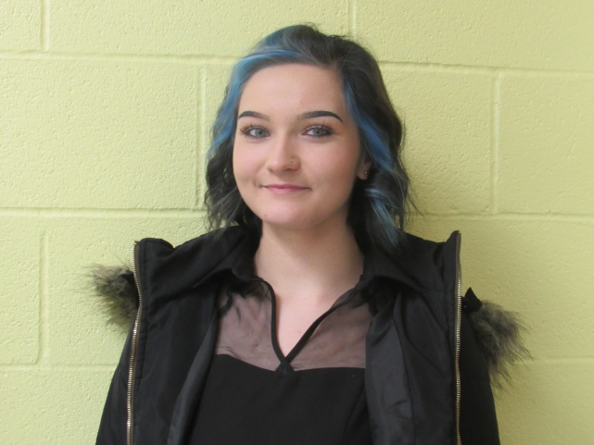After high school, Lindsay plans on graduating William Woods University with a psychology degree, working at the state hospital in Fulton, MO, and putting her cat, Bella, through service animal training. She looks forward to someday being married with one kid, living in a nice little house, and starting a kitten rescue organization.

Lindsay remembers putting time and effort into her class functions. However, she also remembers struggling to find where she belongs: “It took me a while to understand that no one can help me more than myself…I’m stepping up and powering through life.” She has no specific role models; her views have made her “a combination of many different people.” Her advice to the underclassmen: “Life only gets harder from here: learn how to balance your time…High school is as simple as it gets, so do your best.”

**Sports Highlights**

The Calhoun Eagles started their basketball season by hosting the Sherwood Marksman on Friday November 17. The boys kept a strong lead all night, winning the game. The girls started strong, but ended up losing a close game. On Tuesday, November 28, they played the Northwest Mustangs at Hughesville. Both the boys and the girls made a good effort, but did not win either game. The Calhoun Eagles will also be participating in the Tiger Classic in Kingsville December 4-9.

**Official Roster for the Calhoun Eagles—Athletic Director, Ron Kreisel**

|  |  |  |
| --- | --- | --- |
| Eagles | Grade | Number |
| Andy Redding | 12th | 5 |
| Nicholas Rusche | 11th | 14 |
| Anthony Hilbert | 12th | 15 |
| Tristan Isabell | 10th | 30 |
| Ian Cooper | 10th | 32 |
| David Boonstra | 12th | 33 |
| Manager: Trenton Richey | | |
| Coach: Jon Stackhouse | | |

|  |  |  |
| --- | --- | --- |
| Lady Eagles | Grade | Number |
| Taylor Trull | 12th | 3 |
| Kendra Phillips | 12th | 4 |
| Tylar White | 11th | 20 |
| Elana Hollinger | 12th | 23 |
| Rachel Kelso | 11th | 25 |
| Elizabeth Thomas | 9th | 32 |
| Manager: Desi Bailey | | |
| Coach: Mike Lamb | | |
| Assistant Coach: Dakota Ioanis | | |

|  |  |
| --- | --- |
| Varsity Cheerleaders | Grade |
| Captain: Taylor Trull | 12th |
| Co-Captain: Elana Hollinger | 12th |
| Kendra Phillips | 12th |
| Hayli Watson | 11th |
| Tylar White | 11th |
| Jessica Price | 10th |
| Gracie Hollinger | 10th |
| Elizabeth Thomas | 9th |
| Coach: Brittany Riecke | |

**Calhoun vs. Sherwood Stats, November 17, 2017**

|  |  |  |  |  |  |
| --- | --- | --- | --- | --- | --- |
| Eagles | Points | Rebounds | Assists | Steals | Blocks |
| Andy Redding | 36 | - | 8 | 4 | - |
| Anthony Hilbert | 21 | 10 | - | - | 3 |
| David Boonstra | 10 | 7 | - | - | - |
| Nicholas Rusche | 2 | - | - | - | - |
| Tristan Isabell | - | 3 | - | - | - |
| Ian Cooper | - | 2 | 2 | 2 | 1 |

|  |  |  |
| --- | --- | --- |
| Lady Eagles | Points | Rebounds |
| Tylar White | 11 | 10 |
| Rachel Kelso | 11 | 9 |
| Elana Hollinger | 7 | - |
| Taylor Trull | 2 | - |
| Libby Thomas | 2 | - |

|  |  |  |
| --- | --- | --- |
| Eagles vs.  Freshman Marksman | 1st Half | Game |
| Score | 46-24 | 69-48 |

|  |  |  |  |  |  |
| --- | --- | --- | --- | --- | --- |
| Lady Eagles vs.  JV Lady  Marksman | 1st  Quarter | Half | 3rd  Quarter | 4th  Quarter | Game |
| Score | 11-7 | 19-9 | 4-16 | 10-16 | 33-41 |

**Calhoun vs. Northwest Stats, November 28, 2017**

|  |  |
| --- | --- |
| Eagles vs. Mustangs | Lady Eagles vs. Lady Mustangs |
| 50-70 | 36-54 |

**Brackets for Tiger Classic @ Kingsville, December 4-9**





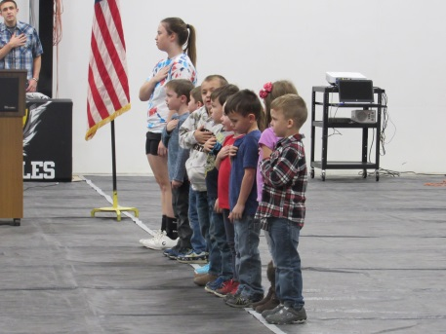**Veteran’s Day**

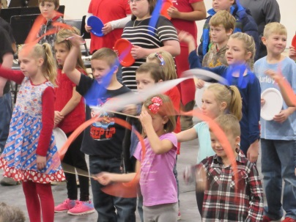On November 10, Calhoun R-VIII honored our veterans. They were welcomed that morning with a breakfast and then cheered for by the elementary students, as the veterans made their way to the assembly waiting for them in the gym. The Color Guard was presented by Anthony Hilbert and David Boonstra, and then Student Council President Elizabeth Thomas gave a welcome speech. The *Star Spangled Banner* was performed by the HS Band, followed by the *Pledge of Allegiance*, led by the Kindergarten.

Kimber Marriott, Emmaleigh Smith, and Trevor Fields gave a sweet performance of Cheryl Dyson’s poem “Veterans Day.” They were followed by the 3rd-6th Grades performing *This Flag We Fly*, who were then joined by the Kindergarten and 1st-2nd Grade for an exhilarating rendition of *You’re a Grand Old Flag*, which included dancing with colorful streamers and plates. Anthony Hilbert concluded this portion of the assembly by reciting the patriotic poem “To Honor the Veterans.”

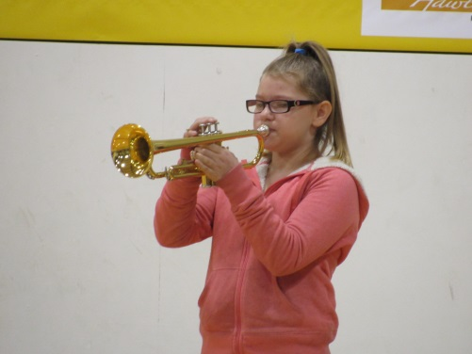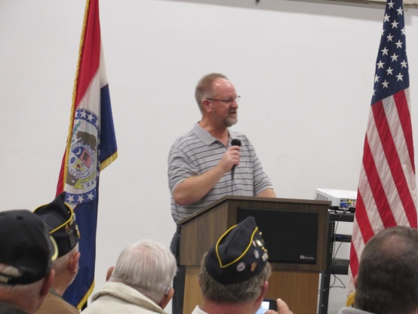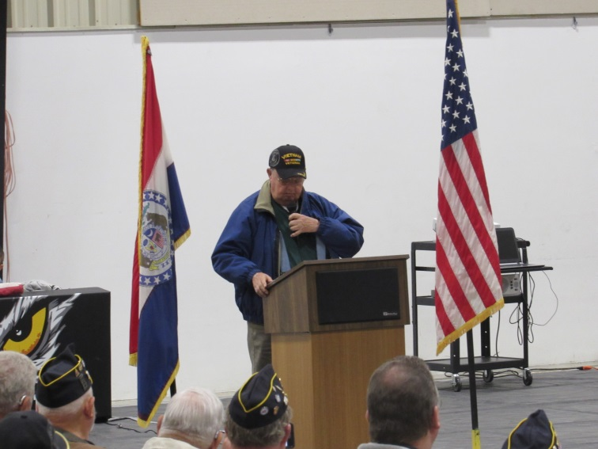Our guest speakers for the morning were James Burson and our current mathematics teacher, Mr. Lamb. Mr. Burson told us stories of his time in the Air Force with passion and excitement; Mr. Lamb, equally passionate, gave us a glimpse of what it’s like to be away from family when serving in the military and how grateful military personnel are for the sacrifices their families make. All of the veterans then had the opportunity to stand for their branches during the *Medley of Armed Forces* video.

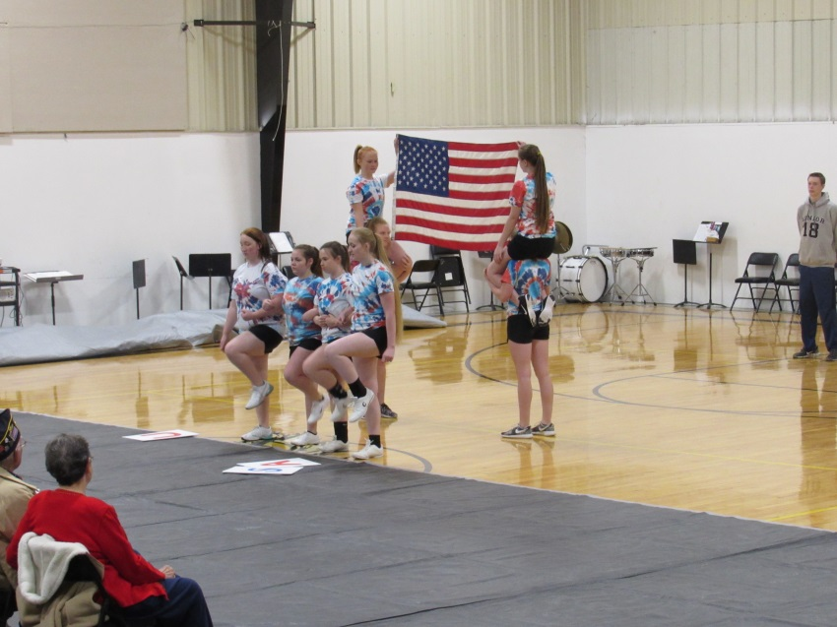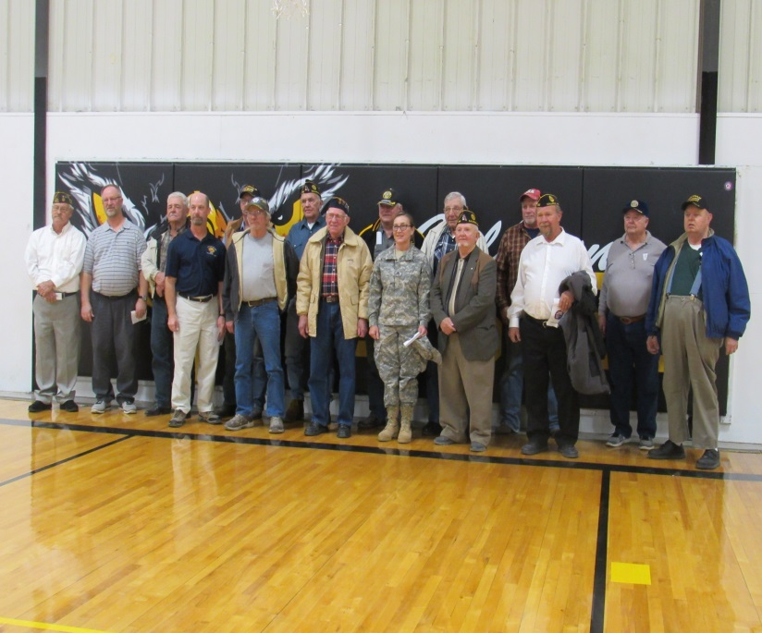To conclude the assembly, the HS and 6th Grade Bands performed *Patriotic Salute*. Then, the HS Cheerleaders gave a honorable performance of *God Bless the USA*. Finally, the room fell still, as Autumn Rusche played Taps and moved us all. Our veterans then lined the gym wall, and the students took a moment to shake hands and thank the veterans for their service and dedication. It was a sweet ending to a respectful assembly.

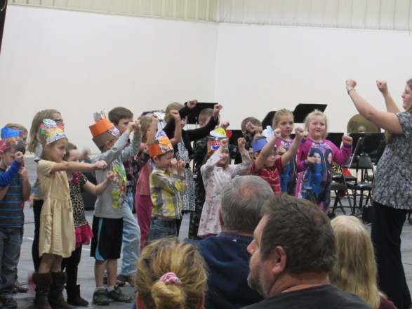**Grandparents’ Day**

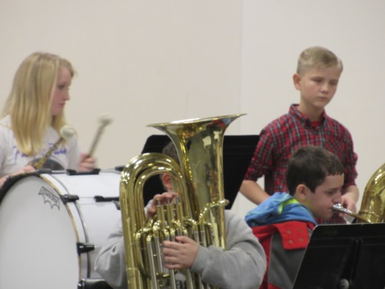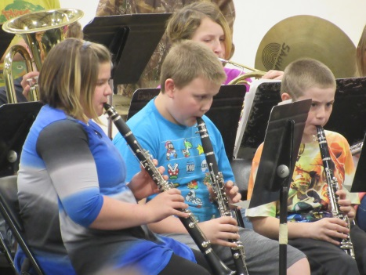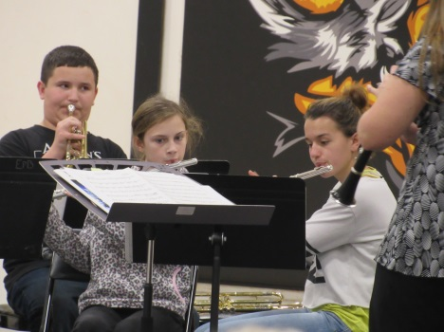November 17, 2017, brought us a turkey dinner and beloved grandparents. After a delightful Thanksgiving dinner in the cafeteria, the grandparents were welcomed into the gym for a concert in their honor. The 3rd-6th Grades sang *This Flag We Fly* and *Just Chillin’*. The Kindergarten and 1st-2nd Grades sang *Mittens and Gloves*; the also encored *You’re a Grand Old Flag* from the Veteran’s Day assembly. The Elementary and JH Bands performed *Cousin Louie*, while the 6th Grade and HS Bands encored *Patriotic Salute* form the Veteran’s Day assembly. The HS Band also performed *Let’s Get It Started*. The students loved spending the afternoon with their grandparents.

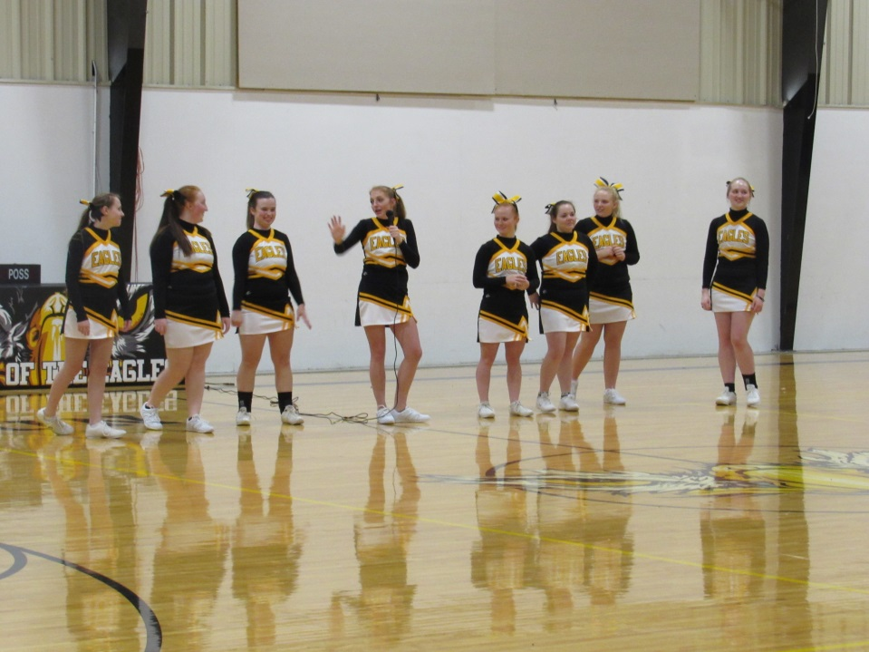**Pep Rally**

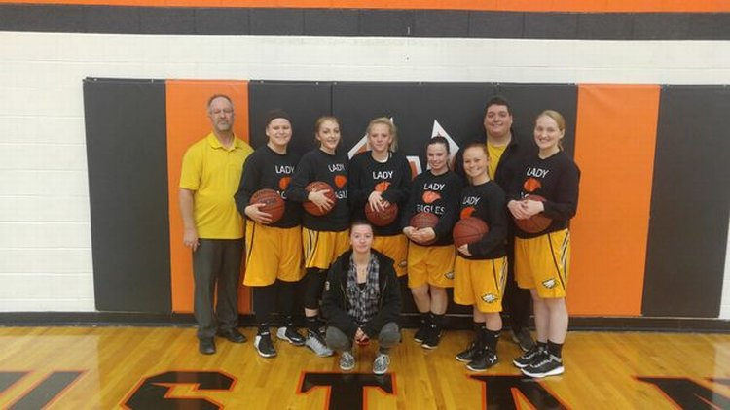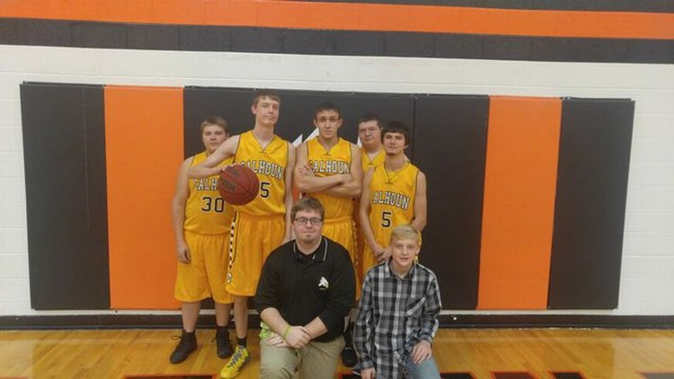Our first pep rally of the year had students and teachers alike up and moving. We were introduced to this year’s Eagles and Lady Eagles and their coaches/manager. The HS Cheerleaders did a fantastic job getting people to participate in cheers and games. The Hoola-Hoop Chain challenged their spatial awareness by using kids of all heights. The Blindfold race was a sight to be seen, with the blindfolded students being directed by the ones they were leading. Then, the race was definitely on, as the coaches all had to move a cookie from their foreheads into their mouths without using their hands. The competition was intense, to say the least, but Coach Kreisel finally achieved victory, prompting thunderous applause and cheering from his all his fans. The energetic assembly ended with celebratory dancing, and everyone had a blast.

Dear Eagle Community,

We made it through the Thanksgiving holiday break and are now looking toward Christmas. This is a magical time of year, but also one of the most challenging as a teacher! The students have their minds focused on the joys of the season and it is our job to help keep them focused despite all of the distractions!

This past month has been great at Calhoun R-VIII. We continue to achieve high attendance, students are engaged and learning, and we received notice that we are now fully accredited! The students at this school deserve the best and should be recognized for their abilities to achieve at high levels. The teachers and staff work hard every day to see that all students are provided with a high quality education. This move from provisional to fully accredit is an example of what the Eagles can accomplish.

I was so impressed with the staff and students at Calhoun for the hard work they put into the Veteran’s Day breakfast and assembly and then the Thanksgiving Feast for Grandparents/Senior Citizens proved also to be a success. The hard work that goes into these things is always appreciated by all.

December will be full of fun activities and chances for parents to be a part of what is going on. Basketball was tipped off in a game vs. Sherwood on November 17 with many more chances scheduled in December through February for you to cheer on our boys and girls. A Literacy Night is planned for Tuesday, December 5, and music is on the calendar for December 12, and many more exciting things are sure to be added as we near the next holiday break.

I look forward to seeing many of you as you come out to support our school. Thank you for what you do to make this a great place for all of us!

Happy Holidays!

Ms. Russell

**Music Notes**

This fall has been a busy one for the Music Department.

Our **Eagle Pride Band** marched at the Colt Show, Leeton Fair, and Windsor and UCM Homecoming parades, as well as performed in the mass band at UCM’s football game. The students represented themselves and the school well at each showing.

This year we have two **elementary bands**: Beginning Band, with 5th and 6th grade members, and Advanced Band. Our elementary bands meet with the JH Band time three days a week. This allows the JH Band to mentor and help the students to progress at a quicker pace. Our Beginning Band has mastered their first 6 notes—this includes reading music, fingerings, embouchure, breath support, and tonguing simultaneously. Our Advanced Elementary Band has risen to the challenge of playing with the JH/HS band on certain pieces. I am looking forward to seeing how far we can progress this year!

**Elementary Music** played instruments, moved, and explored music. We were able to take 3rd- 6th grades to see the Kansas City Symphony perform on Oct 17! This was great fun; they had an Out of this World program mixing music with space exploration. Our very own Madalyn Ross won the writing composition contest and was recognized on stage.

**Fall Fundraiser**:Oct 17 we started our fall fundraiser. With great support from the community, we raised money for instrument repairs and ordering more elementary instruments!

**Veteran’s Day and Grandparents’ Day Assemblies**: Elementary Music performed, and the Advanced Elementary Band played with the JH/HS Band for both our veteran and grandparent guests on November 10 and 17, respectfully. I heard many compliments on how well the band played.

**Christmas Concert and Art Show** will be December 12, starting at 6:00 pm. All students report at 5:30. Please come out and support our students.

**JH Honor Band**: Three of our students were selected to participate in the JH Honor Bands, which will take place Jan 13 at the Smith-Cotton JH: Reese Hartgrave, Autumn Rusche, and Arionna Watson. The concert starts at 5:00 with the District Jazz Band playing first.

Thank you for supporting our students in their musical endeavors and their Music Department.

Musically yours,

Michal Hopkins

Calhoun R-VIII School District

409 S College Street

Calhoun, MO 65323



Mr. John Thompson Ms. Amber Russell

Superintendent K-12 Principal

660-694-3422 660-694-3422

Dear Community Members,

The district should be extremely proud of the Annual Performance Report (APR) that came out in November. The district increased its total point score by 23.2% over the 2016 score of 66.7%. According to the MSIP 5 criteria, the school district is in the Accredited category.

This level of improvement is accomplished by a concerted effort on the part of the teachers, students, staff and community.

I congratulate you all on a job well done!

|  |  |  |  |  |
| --- | --- | --- | --- | --- |
|  | **2014** | **2015** | **2016** | **2017** |
| **APR Total Points** | **90.5/140** | **125.5/138** | **92.0/138** | **124.0/138** |
| **Percent of Points** | **64.6%** | **90.9%** | **66.7%** | **89.9%** |

Respectfully,

John Thompson

John Thompson

Superintendent

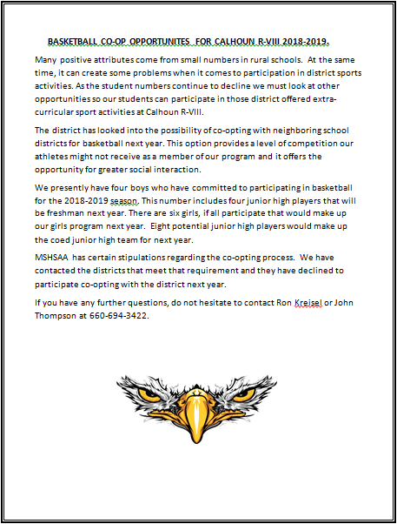

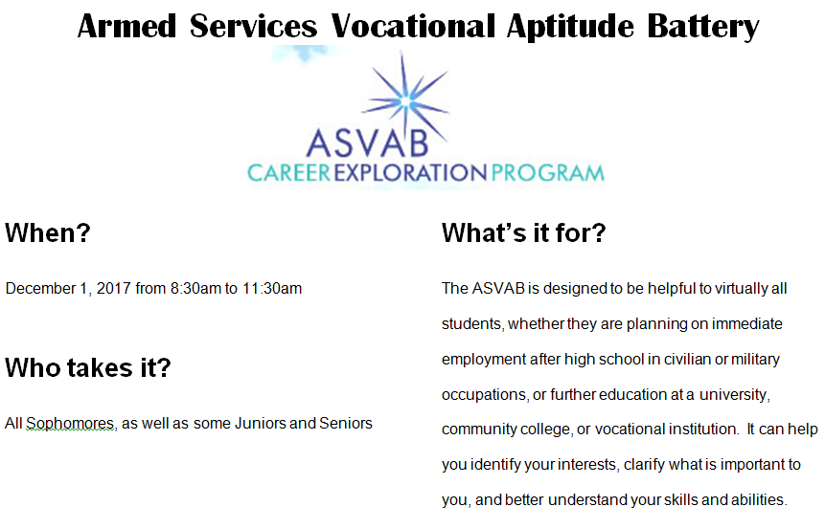

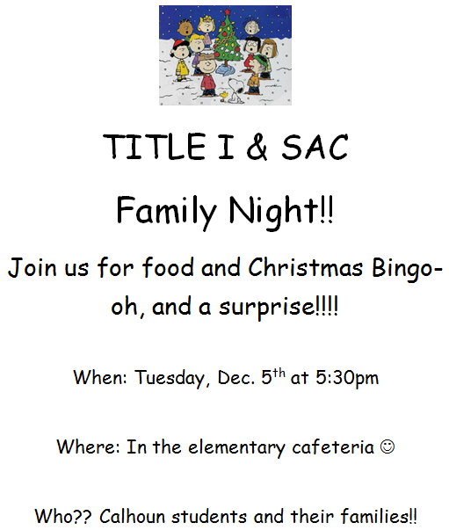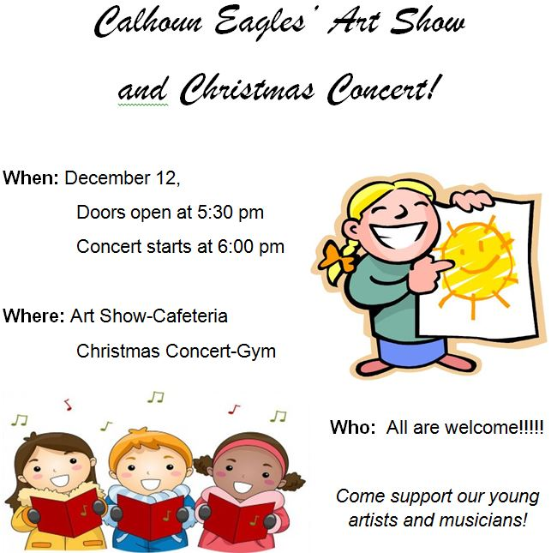

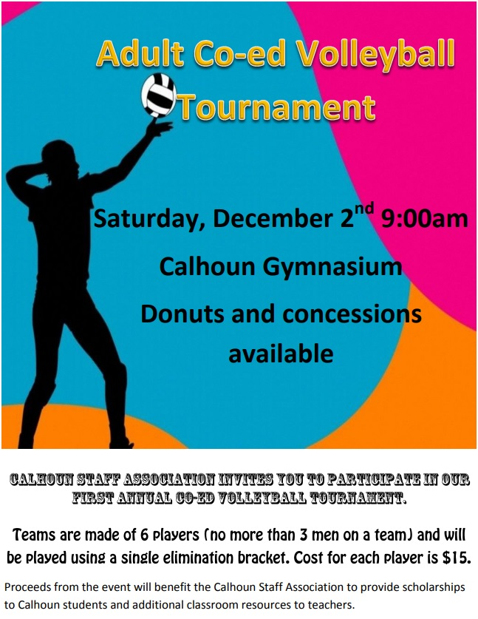

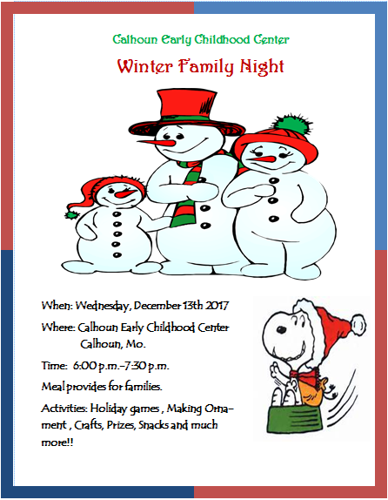

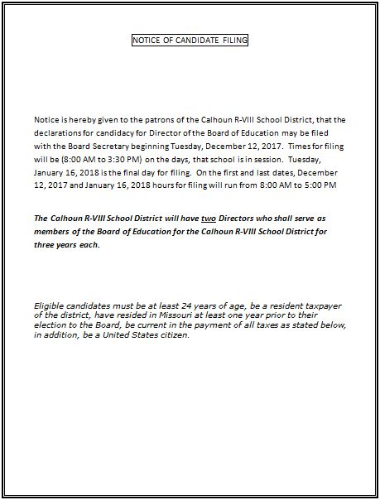

|  |  |  |  |  |  |  |  |  |  |  |  |  |  |  |  |  |  |  |  |  |
| --- | --- | --- | --- | --- | --- | --- | --- | --- | --- | --- | --- | --- | --- | --- | --- | --- | --- | --- | --- | --- |
| **FINANCIAL STATEMENT FOR THE MONTH OF OCTOBER 2017** | | | | | | | | | | | | | | | | | | | | |
|  |  |  | |  | | |  |  | | |  |  | | |  | | |  |  |  |
|  | | | **INCIDENTAL** | |  | **TEACHER** | | |  | **DEBT SERVICE** | | |  | **CAPITAL IMP** | |  | **TOTAL** | | | |
|  | | | **FUND 1** | |  | **FUND 2** | | |  | **FUND 3** | | |  | **FUND 4** | |  |  | | | |
|  | | |  | |  |  | | |  |  | | |  |  | |  |  | | | |
| Beginning Bal Oct 1, 2017 | | | $56,477.79 | |  | ($79,850.20) | | |  | $0.00 | | |  | $18,000.00 | |  | ($5,372.41) | | | |
| Receipts through Oct 31, 2017 | | | $132,235.15 | |  | $119,550.14 | | |  | $0.00 | | |  | $0.00 | |  | $251,785.29 | | | |
|  | | |  | |  |  | | |  |  | | |  |  | |  |  | | | |
| TOTALS | | | $188,712.94 | |  | $39,699.94 | | |  | $0.00 | | |  | $18,000.00 | |  | $246,412.88 | | | |
| Disbursements through Oct 31, 2017 | | | $169,651.71 | |  | $114,625.59 | | |  | $0.00 | | |  | $13,825.00 | |  | $298,102.30 | | | |
|  | | |  | |  |  | | |  |  | | |  |  | |  |  | | | |
|  | | |  | |  |  | | |  |  | | |  |  | |  |  | | | |
| Balance Oct 31, 2017 | | | $19,061.23 | |  | ($74,925.65) | | |  | $0.00 | | |  | $4,175.00 | |  | ($51,689.42) | | | |
|  | | |  | |  |  | | |  |  | | |  |  | |  |  | | | |
|  | | |  | |  |  | | |  |  | | |  |  | |  |  | | | |
|  | | |  | |  |  | | |  |  | | |  |  | |  |  | | | |
|  |  |  |  | |  |  | | |  |  | | |  |  | |  |  | | | |
| Beginning Balance July 1, 2017 | | | $59,879.47 | | | | | | | | | | | | | | | | | |
| YTD Receipts through Oct 31, 2017 | | | $785,627.51 | | | | | | | | | | | | | | | | | |
|  | | |  | |  |  | | |  |  | | |  |  | |  |  | | | |
| TOTALS | | | $845,506.98 | | | | | | | | | | | | | | | | | |
| YTD Disbursements through October 31, 2017 | | | $897,196.40 | | | | | | | | | | | | | | | | | |
|  | | | ______________ | | | | | | | | | | | | | | | | | |
| TOTALS | | | ($51,689.42) | | | | | | | | | | | | | | | | | |
|  | | |  | |  |  | | |  |  | | |  |  | |  |  | | | |
| LESS INVESTMENTS | | | $0.00 | | ** | | | |  |  | | |  |  | |  |  | | | |
|  | | | ______________ | | | | | | | | | | | | | | | | | |
| OPERATING BALANCE October 31, 2017 | | | ($51,689.42) | | | | | | | | | | | | | | | | | |
|  |  |  | |  | | |  |  | | |  |  | | |  | | |  |  |  |
|  |  |  | |  | | |  |  | | |  |  | | |  | | |  |  |  |
|  |  |  | |  | | |  |  | | |  |  | | |  | | |  |  |  |
| $17,236.78 | CERTIFICATE OF DEPOSIT | | | | | | | | | | | | | | | | | | | |
| $200.00 | PETTY CASH | | | | | | | | | | | | | | | | | | | |
|  |  |  | |  | | |  |  | | |  |  | | |  | | |  |  |  |

|  |  |  |  |  |  |  |  |
| --- | --- | --- | --- | --- | --- | --- | --- |
| |  | | --- | | **Calhoun R-VIII - Lunch Menu for December 2017** | | | | | | | |
| **Sun** | **Mon** | **Tue** | **Wed** | **Thu** | **Fri** | **Sat** |
|  |  |  |  |  | **1**  **Breakfast**  Breakfast sandwich, cook's choice, sweet potato fries, fruit, juice, milk.  **Lunch**  Grilled cheese sandwich, soup of cook's choice, fruit/veg bar, milk. | **2** |
| **3**  **Breakfast**  Breakfast and lunch menu are subject to change.  **Lunch**  "This institution is an equal opportunity provider." | **4**  **Breakfast**  Scrambled eggs, sausage, toast, fruit, juice, milk.  **Lunch**  Chicken nachos, corn, fruit/veg bar, milk. | **5**  **Breakfast**  Sausage pancake on a stick, pineapple, juice, milk.  **Lunch**  Hotdog on bun, baked beans, fruit/veg bar, milk. | **6**  **Breakfast**  Pancake or waffle, cook's choice, pears, juice, milk.  **Lunch**  Chicken stir fry rice, steam veggies, fruit/veg bar, milk. | **7**  **Breakfast**  Biscuit and gravy, peaches, juice, milk.  **Lunch**  Baked potato, cottage cheese, bread stick, fruit/veg bar, milk. | **8**  **Breakfast**  Breakfast sandwich, cook's choice, sweet potato fries, fruit, juice, milk.  **Lunch**  Chicken patty on bun, chips, fruit/veg bar, milk. | **9** |
| **10** | **11**  **Breakfast**  Scrambled eggs, sausage, toast, fruit, milk.  **Lunch**  Cheeseburger on bun, oven fries, fruit/veg bar, milk. | **12**  **Breakfast**  Sausage pancake on a stick, pineapple, juice, milk.  **Lunch**  Oven baked chicken, veggies with cheese, bread stick, fruit/veg bar, milk. | **13**  **Breakfast**  Pancake or waffle, cook's choice, fruit, juice, milk.  **Lunch**  Spaghetti, green beans, fruit/veg bar, milk. | **14**  **Breakfast**  Biscuit and gravy, peaches, juice, milk.  **Lunch**  Taco salad, refried beans, fruit/veg, juice, milk. | **15**  **Breakfast**  Breakfast sandwich, cook's choice, sweet potato fries, fruit, juice, milk.  **Lunch**  Chicken and waffle, fruit/veg bar, milk. | **16** |
| **17** | **18**  **Breakfast**  Scrambled eggs, sausage, toast, fruit, juice, milk.  **Lunch**  Breaded chicken patty, mashed potato and gravy, green beans, fruit/veg bar, milk. | **19**  **Breakfast**  Sausage pancake on a stick, pineapple, juice, milk.  **Lunch**  Goulash, steamed veggies, fruit/veg bar, milk. | **20**  **Breakfast**  NO SCHOOL  **Lunch**  WINTER BREAK | **21**  **Breakfast**  NO SCHOOL  **Lunch**  WINTER BREAK | **22**  **Breakfast**  NO SCHOOL  **Lunch**  WINTER BREAK | **23** |
| **24** | **25**  **Breakfast**  NO SCHOOL  **Lunch**  WINTER BREAK | **26**  **Breakfast**  NO SCHOOL  **Lunch**  WINTER BREAK | **27**  **Breakfast**  NO SCHOOL  **Lunch**  WINTER BREAK | **28**  **Breakfast**  NO SCHOOL  **Lunch**  WINTER BREAK | **29**  **Breakfast**  NO SCHOOL  **Lunch**  WINTER BREAK | **30** |
| **31** |  |  |  |  |  |  |