February 22, 2018
Families,
It is an exciting end to the month….Reading Week is scheduled for February 26-March 2 and at Amargosa Valley Elementary/Middle School, we plan to celebrate it!! Our activities for the week will include:
Drop Everything and Read—Everyday during the week, an announcement will be made at some point within the day for everyone to drop what they are doing and read for 10 minutes.

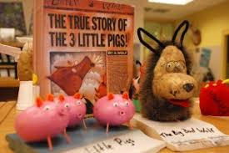
Decorate a POTATO as your favorite book character—Students are being challenged to decorate a russet (brown) potato to imitate their favorite book character. Decorated potatoes are due to Miss Lindie in the office by NOON on Wednesday, February 28th. The winner will be announced on Friday, March 2nd during the movie.

The Lorax—On Friday, students, school-wide, will be able to view the movie The Lorax beginning at 9:30AM in the community center.

Dress Days—
Monday Tuesday Wednesday Thursday Friday
Dr. Seuss’ Birthday
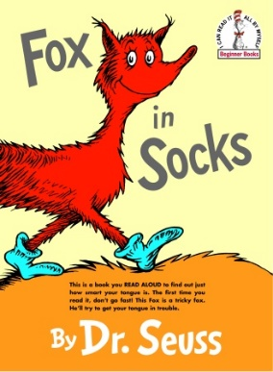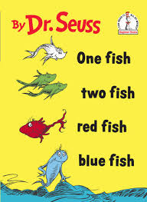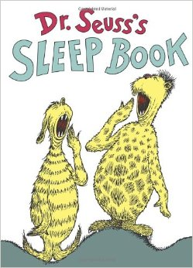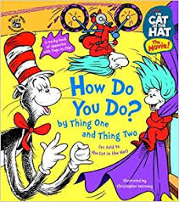
Silly or Wear Red & Blue Pajama Day Twin Day Favorite Hat Day
Mismatched
Socks Day

We look forward to your student’s participation in Read Across America Week!!

Thank You,

Mrs. Melinda Jeffrey
Assistant Principal

