ROSEMARY CLARKE MIDDLE SCHOOL (2016-17)

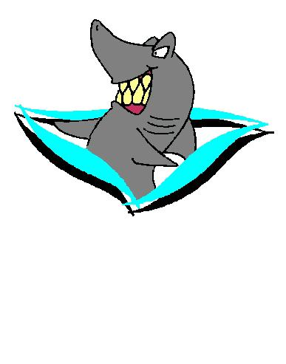
“Swimming to the Top”

SUPPLY LIST – ALL GRADES
___Black or blue pens & a red pen ___Colored pencils OR markers
___Ruler ___Protractor
___Paper (ongoing supply) – college ruled ___Compass (7th and 8th grades)
___Glue sticks ___Highlighter pen & 4 Dry Erase Markers
___3-ring binder with dividers, spiral notebooks, pocket folders, and 2 Composition Notebooks
___Pencils (2 at all times) – mechanical pencils with extra lead OR wood pencils with a hand pencil
Sharpener- (Please provide as many pencils as you can)
___8th grade students ONLY – Lots of pencils/erasers, spiral notebook, glue sticks, dry erase markers
(assorted colors). Verify with math teacher PRIOR to any calculator purchase.
DRESS CODE
Students’ dress, personal appearance, and conduct are required to be of such character as to not disrupt or detract from the educational environment of the school. Weather and safety MUST be considered in the selection of clothing and shoes.
This dress code is established to ensure and maintain an orderly, undisrupted, school environment free from health and safety issues. Exacerbating messages and provocative displays, whether intentional or unintentional, are forbidden. These provisions are also designed to prevent students from carrying concealed weapons or for providing a means for staff to immediately identify students by preventing clothing that allows students to obscure any part of their head or face. Please obey the following requirements for all RCMS students:
- Administration will have the discretion to determine the appropriateness of school attire.
- No skin shall be visible beyond 2” above the knee when wearing shorts, skirts, pants, skorts, dresses or any other “below the waist” attire. (No higher than mid-thigh is expected)
- Leggings/yoga pants must be covered by skirt, shorts, or shirt to at least 4 inches above the knee. (RCMS only)
- No sagging pants- oversized pants need to be worn with a belt. Pants, shorts, and skirts are to be worn on hips or above.
- Undergarments (boxers, bras, tighty-whities, gym shorts, etc.) should not be visible or seen at ANY TIME.
- Pajama pants and slippers are forbidden at school.
- No see-through or bare belly shirts or blouses (this includes off-color bras that bring attention to the undergarments of an individual.)
- Shirts are not allowed to be low cut, or loose and revealing, showing any part of the chest or torso.
- Tops must have sleeves. (Again, undergarments must be covered)
- Shoes will be worn at all times. Open-toed shoes or flip-flops are not recommended due to safety.
- Hats/head coverings are to be worn in the fashion intended for the particular head covering and no head covering will be worn inside a building, including any hood.
- No bandanas, bandana-like headwear, or Do-rags are to be worn or displayed.
- Accessories that could be used as a weapon or pose a danger are forbidden due to safety concerns.
- Any clothes, armbands, handkerchiefs, or jewelry that display gang affiliation, lewd or profane slogans, hate language, ethnic slurs, and/or promote violence, weapons, sex, drugs, tobacco, or alcohol are forbidden.
- Piercings that interfere with the educational environment or pose a danger are forbidden.

Any student who violates the dress code will be sent to the office, may have his/her parents contacted, and student will only be allowed to return to the school environment after complying with the dress code.
The school administration shall have the right to designate which types of dress, fashion, and fads are acceptable at school as well as retain the authority to grant exceptions for special occasions and/or special conditions. Failure to comply with the approved RCMS dress code will result in disciplinary action in accordance with the RCMS progressive discipline plan and the NCSD disciplinary matrix.
**Important information**
- All 7th grade students MUST have a Tdap shot before starting school or an exemption approved by the NCSD School Board.
- Open house/Orientation will be held on August 4th from 4-6 PM at RCMS. (details will be communicated in July/August)
- School begins Monday, August 8th at 7:25 AM. Student day is 7:25 AM to 2:00 PM (M, T, Th, F) Wed: 7:25 AM to 1:25 PM

