**PARENTS OF JUNIORS AND SENIORS ARE INVITED TO ATTEND.**

**FINANCIAL AID AND SCHOLARSHIP WORKSHOP**

**Monday, November 13th**

**Georgetown High Auditorium**

**5:30 PM**

 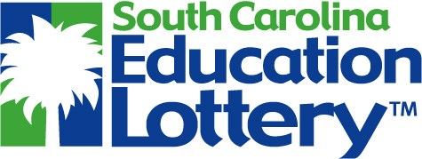 

**Mike Fox with the SC Student Loan Corporation will provide information on the following topics:**

**Scholarships, Grants and Loans**

**FAFSA**

**College Financial Planning**

**LIFE, Palmetto Fellows and HOPE**

**Sponsored by AHS, GHS, and WHS School Counselors.**

**Please contact the guidance office at your school for more information.**