Red Ribbon Week
October 23-26
Red Ribbon Week begins Monday, October 23 and concludes Thursday, October 26.
This is a week in which we support and celebrate saying no to drugs year round.

Red Ribbon Week Fun Days:
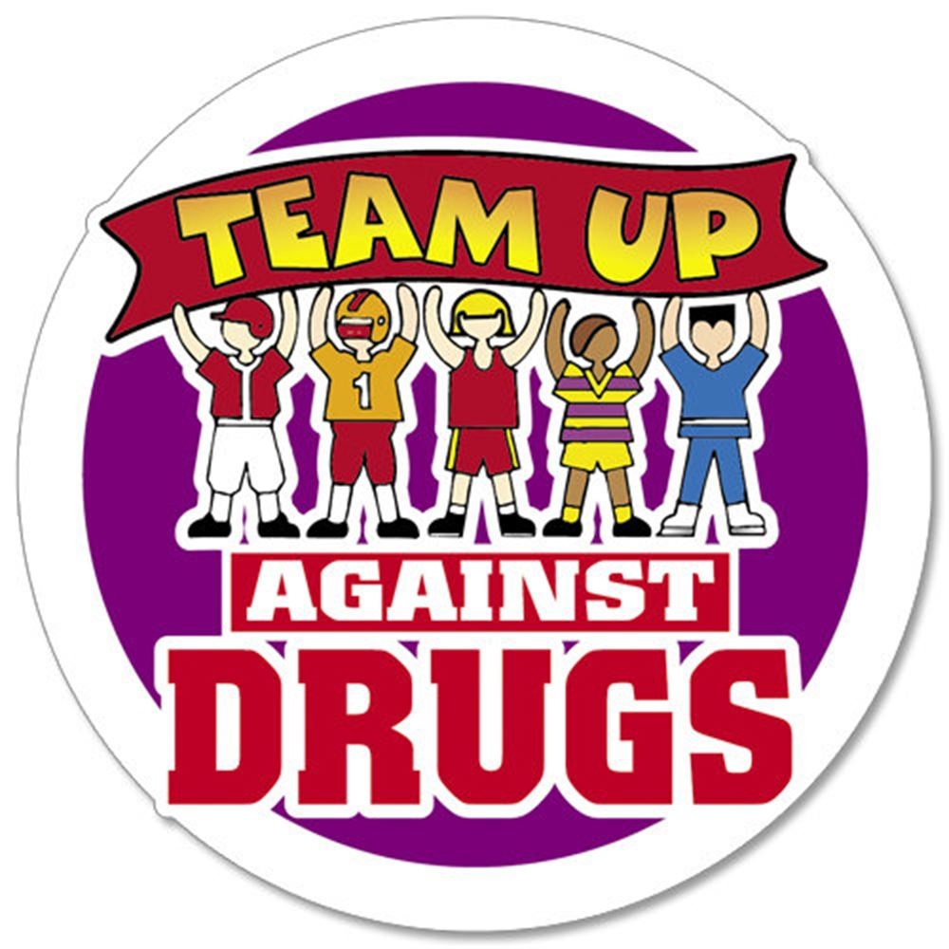

Monday: “Team Up Against Drugs”- wear your favorite team jersey from any sport.
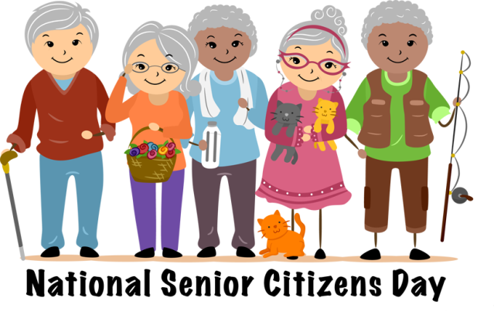

Tuesday: “Senior Citizen Day”- Live longer without drugs!
Wednesday: “Western Wednesday”- Give drugs the boot! - Wear your best western outfit.
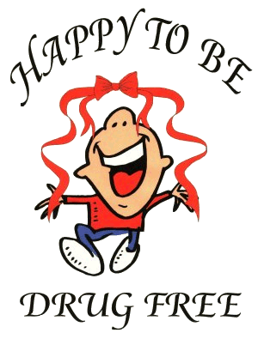
Thursday: “Rally in Red”- Wear as much red as you can today in support of red ribbon week.

***Please remember to remain within the dress code that is outlined in the student handbook.
Cowboy/Cowgirl hats are permitted on Wednesday.

