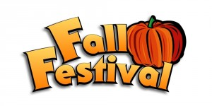

Please mark your calendars to attend our annual Fall Festival on October 14, 2017. We would like to invite each and every one of you to come join the fun. The following is a list of events that will take place during our Fall Festival.

Schedule of Events

3:30 – 4:00 Costume Contest Sign-Up (Lobby)
- $1.00 Entry Fee
- 3 Divisions: Newborn – PreK, K - 2nd grade, 3rd – 5th grade
- 3 Categories: Scariest, Most Original, Cutest
Spaghetti Supper Tickets on Sale (Lobby)
- Adult Plate: $7.00
- Child’s Plate: $4.00
Game Tickets on Sale (Bookstore)
- 4 Tickets = $1.00
- 25 Tickets = $5.00

4:00 – 4:30 Costume Contest (Gym)

4:30 – 5:00 King and Queen (Gym)
- Categories: PreK – 2nd Grade, 3rd – 5th Grade
Royal Class (Gym)
- Trophy Presentation

4:00 – 6:30 Spaghetti Supper (Cafeteria)

4:00 – 7:00 Silent Auction (Cafeteria)

5:00 – 7:00 Games (Classrooms/Gym/Outside)
Concessions (Lobby)

7:00 Live Auction (Cafeteria)

