Holice Powell Annual Spaghetti Supper
Pre-Sell Orders

Our annual Fall Festival and Spaghetti Supper will be held on October 14, 2017. This year we will give everyone the option to purchase their spaghetti supper tickets in advance. Tickets will be $6.00 for an adult plate and $3.00 for a child’s plate. Children will have the option of a spaghetti plate or a hot dog plate. All plates will be served with a drink and a dessert. Tickets will be sold from now until September 29th.

Tickets will still be sold at the door the night of the supper as well. Tickets purchased the night of the spaghetti supper will be $7.00 for an adult plate and $4.00 for a child’s plate.

Attached you will find a blank form for your child to presell tickets. Tickets will be sent home with your child once all the money is collected and turned into the office. Please be sure to fill out all information correctly.

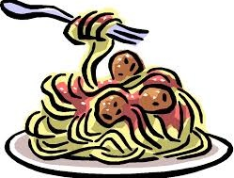
Name: | Phone Number: | Adult  Plates  $6.00 | Child’s  Plates  $3.00 | Total:

