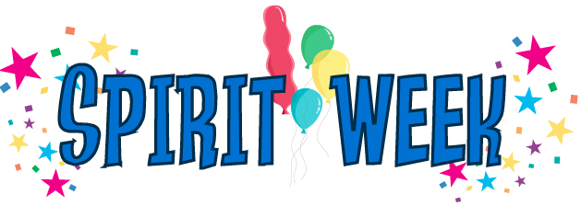

OCTOBER 9TH – 13TH

Let’s make Fall Festival week the most fun ever! Plan on supporting your favorite King or Queen nominees as they sell in the gym each morning. Also, help your class earn the title of the “Royal Class” by bringing in your extra change throughout the week. The class that raises the most money will be crowned the “Royal Class” at the Fall Festival on October 14th at 5:00.

Monday: PENNY PIRATES
Dress in your best PIRATE attire and bring in all your extra PENNIES as loot for your class.

Tuesday: NICKEL NERDS
Nerds rule the day! Help your class be the nerdiest by dressing up as a NERD and bring in your NICKELS.

Wednesday: DASHING DIMES
Wear your most DASHING and DAPPER outfit. Donate as many dimes to your class as possible.

Thursday: COLORFUL QUARTERS
Wear your favorite color from head to toe. Collect and give any quarters you can!

Friday: CHOCTAW PRIDE
We are proud to be Choctaws! Wear your Choctaw colors proudly. Bring any donation you want. ($1 would be great!)

Please continue to work on pre-selling Spaghetti Supper tickets. Turn your money and order forms in by Friday, September 29th.

