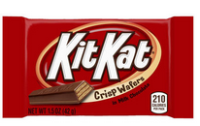
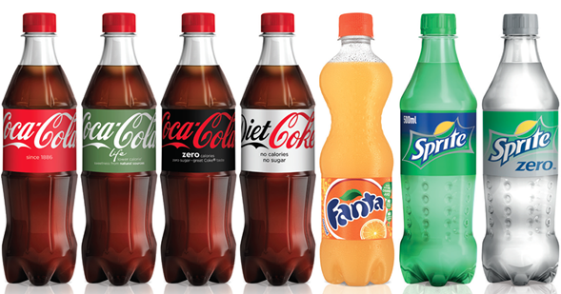
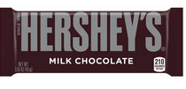

Fall Festival Concessions

As you all know our annual Fall Festival is just around the corner. Each year we ask students to bring in items to be sold at our concessions during Fall Festival. Students should bring the following items to school no later than Thursday, October 12th.

PreK – 2nd Grade: 2 Candy Bars (No Peanuts or Peanut Butter)

3rd – 5th Grade: (1) 2-Liter Drink (Coca-Cola or Pepsi Products)

Volunteer Sign - Ups

Our Fall Festival would not be possible without the help of volunteers. We are asking for volunteers to send cakes, cupcakes, or cookies to be used during the Cake Walk at the Fall Festival. We also need volunteers to help before, during, and after Fall Festival. If you would be interested in either of these, please complete this form and return it to school no later than Friday, September 29th.

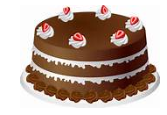
_____ I would like to donate a cake, cupcake, or cookies. (No Nuts or Peanut Butter)

_____ I would like to volunteer to help with Fall Festival.

Parent’s Name: ______________________________

Phone Number: ______________________________

