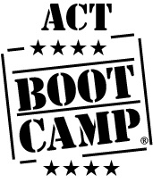

When: Saturday - March 3rd, 10th, 17th – See specifics below 9 am – 12 noon each session
Where: FHS Who: Current Juniors
Why: Prepare for the ACT
Learn techniques
Gain tools and strategies for success

Saturday March 3rd : Science and Test Strategies
Saturday March 10th : ELA/Reading
Saturday March 17th : Math
Incentives:
(just in case you need something other than increasing your knowledge which of course can help increase your score ;)
Prize drawing entry for each day of attendance

Attend all 3 days = Automatic Plinko contestant
Bootcamp Lunch on March 17th (music, lunch, prizes)

