6th Grade Social Studies Summer Assignment: A Preliminary Look at Prehistoric Man with The Boy of the Painted Cave, by Justin Daniel
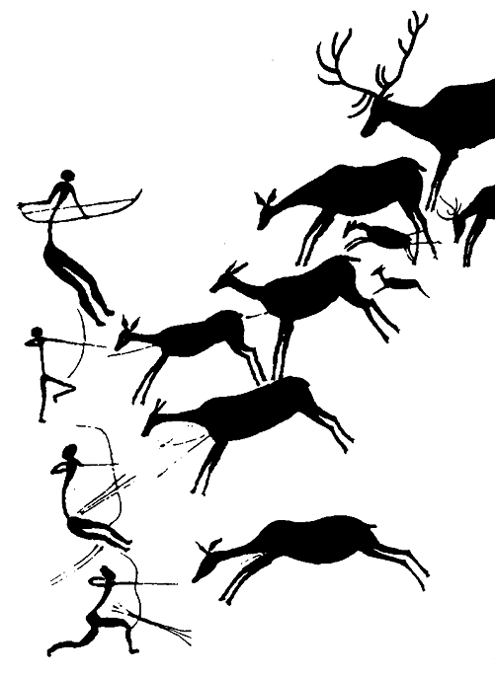
__________________________________________________________________________________________

The first unit we will cover together at the beginning of Quarter 2 focuses on the culture of prehistoric man. To prepare for our investigation into these early people, over the summer you will read the book titled, The Boy of the Painted Cave, by Justin Denzel and complete the attached assignment. This book tells the tale of a young boy in a prehistoric clan who is uninterested in the role he is expected to fill in the group—hunting. The story is filled with details about the culture (foods, jobs, past-times, beliefs, etc.) of Paleolithic (early Stone Age) man and you will collect these details to use later in the fall during your first round of social studies.
The chart attached to this form must be completed either while or soon after you read. If you choose to wait until you finish reading, you will need to mark sections in the book with Post-Its as you go. I would suggest each Post-It contains: the page number of the important text, the first few words of the selection, and the category (from the chart) that connects to the selection of text. You can use these Post-Its later to complete the attached chart.

_________________________________________________________________________________________________________
Due Date: The work you complete for this assignment should be turned in to Mrs. Freeman (Rm. 202) during the first week of school.

Text Analysis of The Boy of the Painted Cave
Use the chart below to gather important cultural details about these prehistoric people. You should find six details for each category of culture in the left-hand column.

 | Page Numbers | Text Citations  (Write the phrase or sentence directly from the text.)
Information Related to the Work Done by Members of the Clan | *  *  *  *  *  * | *  *  *  *  *  *
Information Related to the Shelter or Food of the Clan | *  *  *  *  *  * | *  *  *  *  *  *
Information Related to the Tools Used by the Clan | *  *  *  *  *  * | *  *  *  *  *  *
Information about How Members of the Clan Used Nature for Their Benefit | *  *  *  *  *  * | *  *  *  *  *  *
Information Related to Traditions or Ceremonies Celebrated by the Clan | *  *  *  *  *  * | *  *  *  *  *  *

