LA CLASSE DE MONSIEUR MORGAN
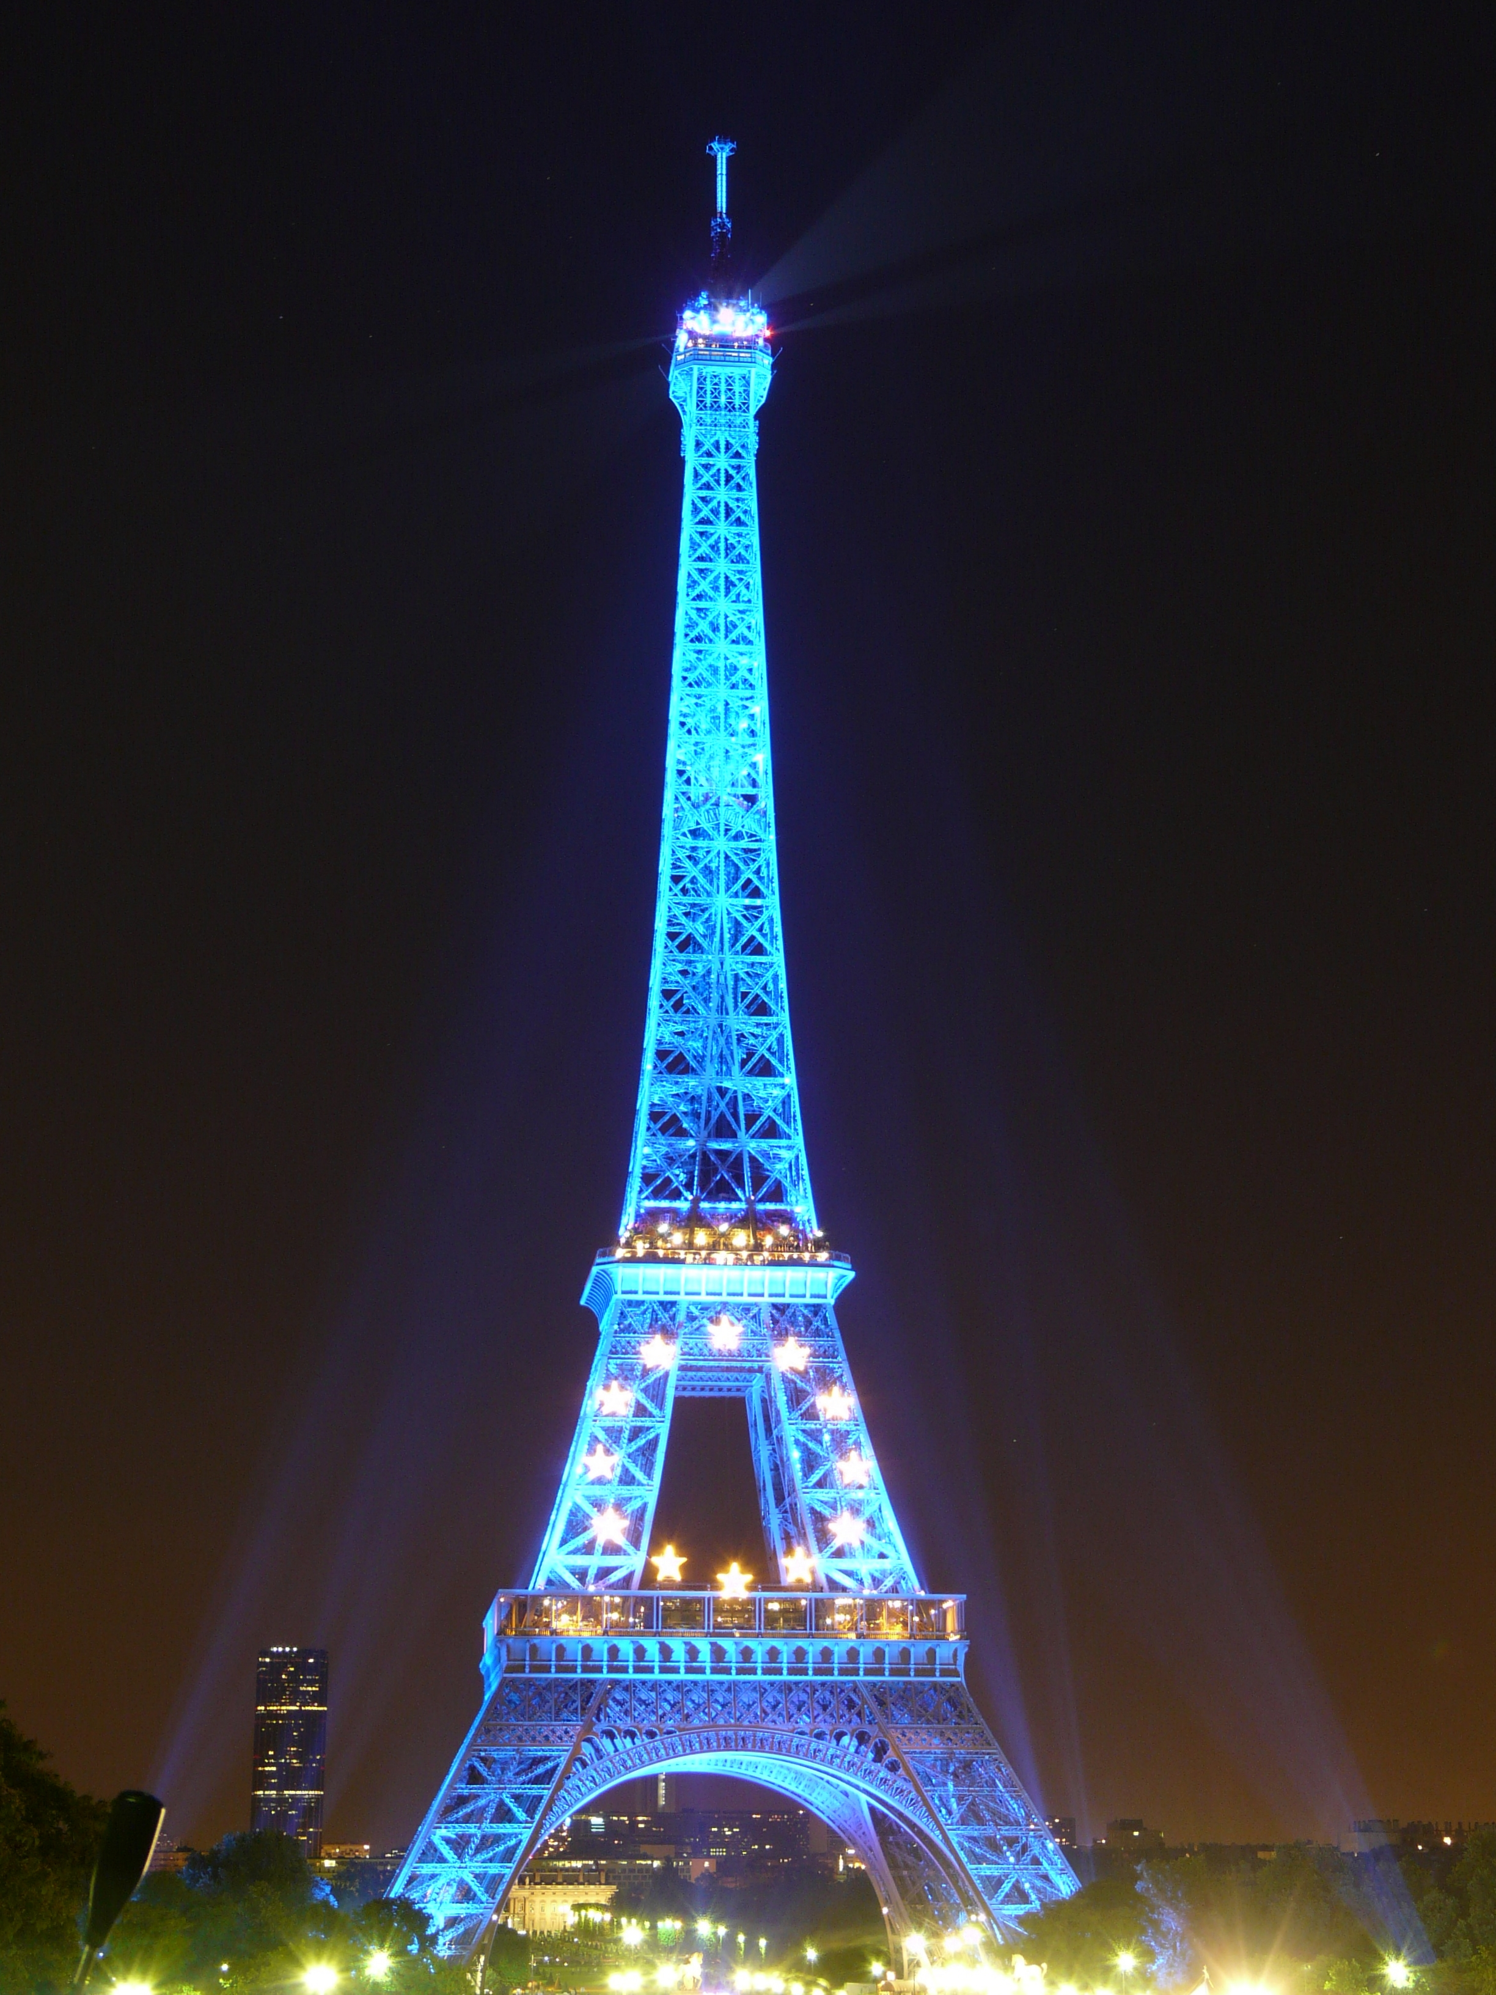

HS 3
CLASS OVERVIEW:
The focus of this honor’s level class is to apply the years of vocabulary and grammar learned in the lower courses to effectively communicate largely through the medium of writing. The cultural focus and primary points of discussion for writing will be French history. To that end, an already established understanding of both tense formation and meaning/usage for the past tenses is essential. Students should focus on the imparfait and passé composé tenses. A review of the plus-que-parfait if having been previously taught would also be helpful. It would be helpful to review those. Students can obtain lists of conjugations forms from the teacher’s webpage on mycsas.com.
Website:
www.mycsas.com
- On the left hand side, search for Academics.
- Click on Teachers and Classes
- Search the list of teachers for Morgan, Daniel; and click
- Click on File Manager
- Click Etudes Terminales (HS III)
- Click “Past Conjugations” it has imparfait conjugations and a list of irregular past participles.
- Also click on “Le Passé Composé” Instructions for formation guidelines.

