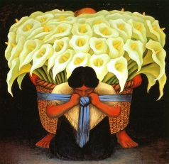
Summer Supplemental List for HS II Spanish
Sra. Johnnie F Richardson
Class Overview:
The grammatical focus of the class will include the Preterit vs. Imperfect, which will be covered in-depth, but in context. When appropriate, we will also examine and discuss important historical and cultural aspects of the Hispanic cultures such as el Día de los Muertos in Mexico. We will also use the video program La Catrina as a way of strengthening listening, reading, speaking and writing skills. Because of the need to strengthen our spoken and written skills, we will focus upon these areas. The students are expected to speak and seminar in Spanish the majority of the time (95%). The seminar pieces include Día de Muertos by Diego Rivera and Caperucita Roja.
Review the following topics:
Adjective agreement
Subject and Verb agreement
Present tense verb conjugations

Grammatical Topics to be covered:
Preterit tense – regular and irregular verbs
Imperfect tense – regular and irregular verbs
Preterit vs. Imperfect – when to use each one

Resources:
Study Spanish www.studyspanish.com
Power Speak Languages gale.powerspeak.com

