Hixson Wildcats Polo Shirt Sale
$20 per polo shirt
A 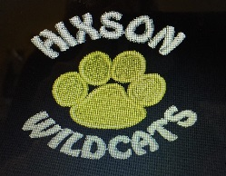 or B 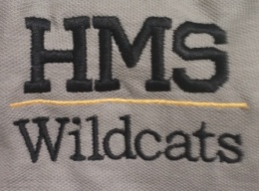 or C 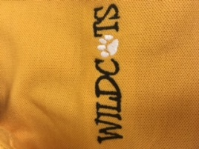
Logo will be embroidered on left chest area. Dress code approved.
Fundraiser for School-Wide STEM Resources

ORDERS DUE BY Thursday, SEPTEMBER 14, 2017
Please allow 2-3 weeks for orders to be delivered to the school after the fundraiser ends.

Student Name: _________________________________________________________________

Grade: __________________ Homeroom teacher: ___________________________________
 | Black shirt w/paw | Gray shirt w/HMS | Gold shirt w/Wildcats
Youth Small
Youth Medium
Youth Large
Youth XLarge
Adult XSmall
Adult Small
Adult Medium
Adult Large
Adult X-Large
Adult 2X Large (add $2)

Total: ________________________ (Make checks payable to Hixson Middle School)
□ Cash □ Check #_______
Parent Name: ______________________________________________________________________
Phone number: __________________________________

