Project: Design and build an Outdoor Classroom for Hixson Middle School

Location: between 6th and 7th grade buildings
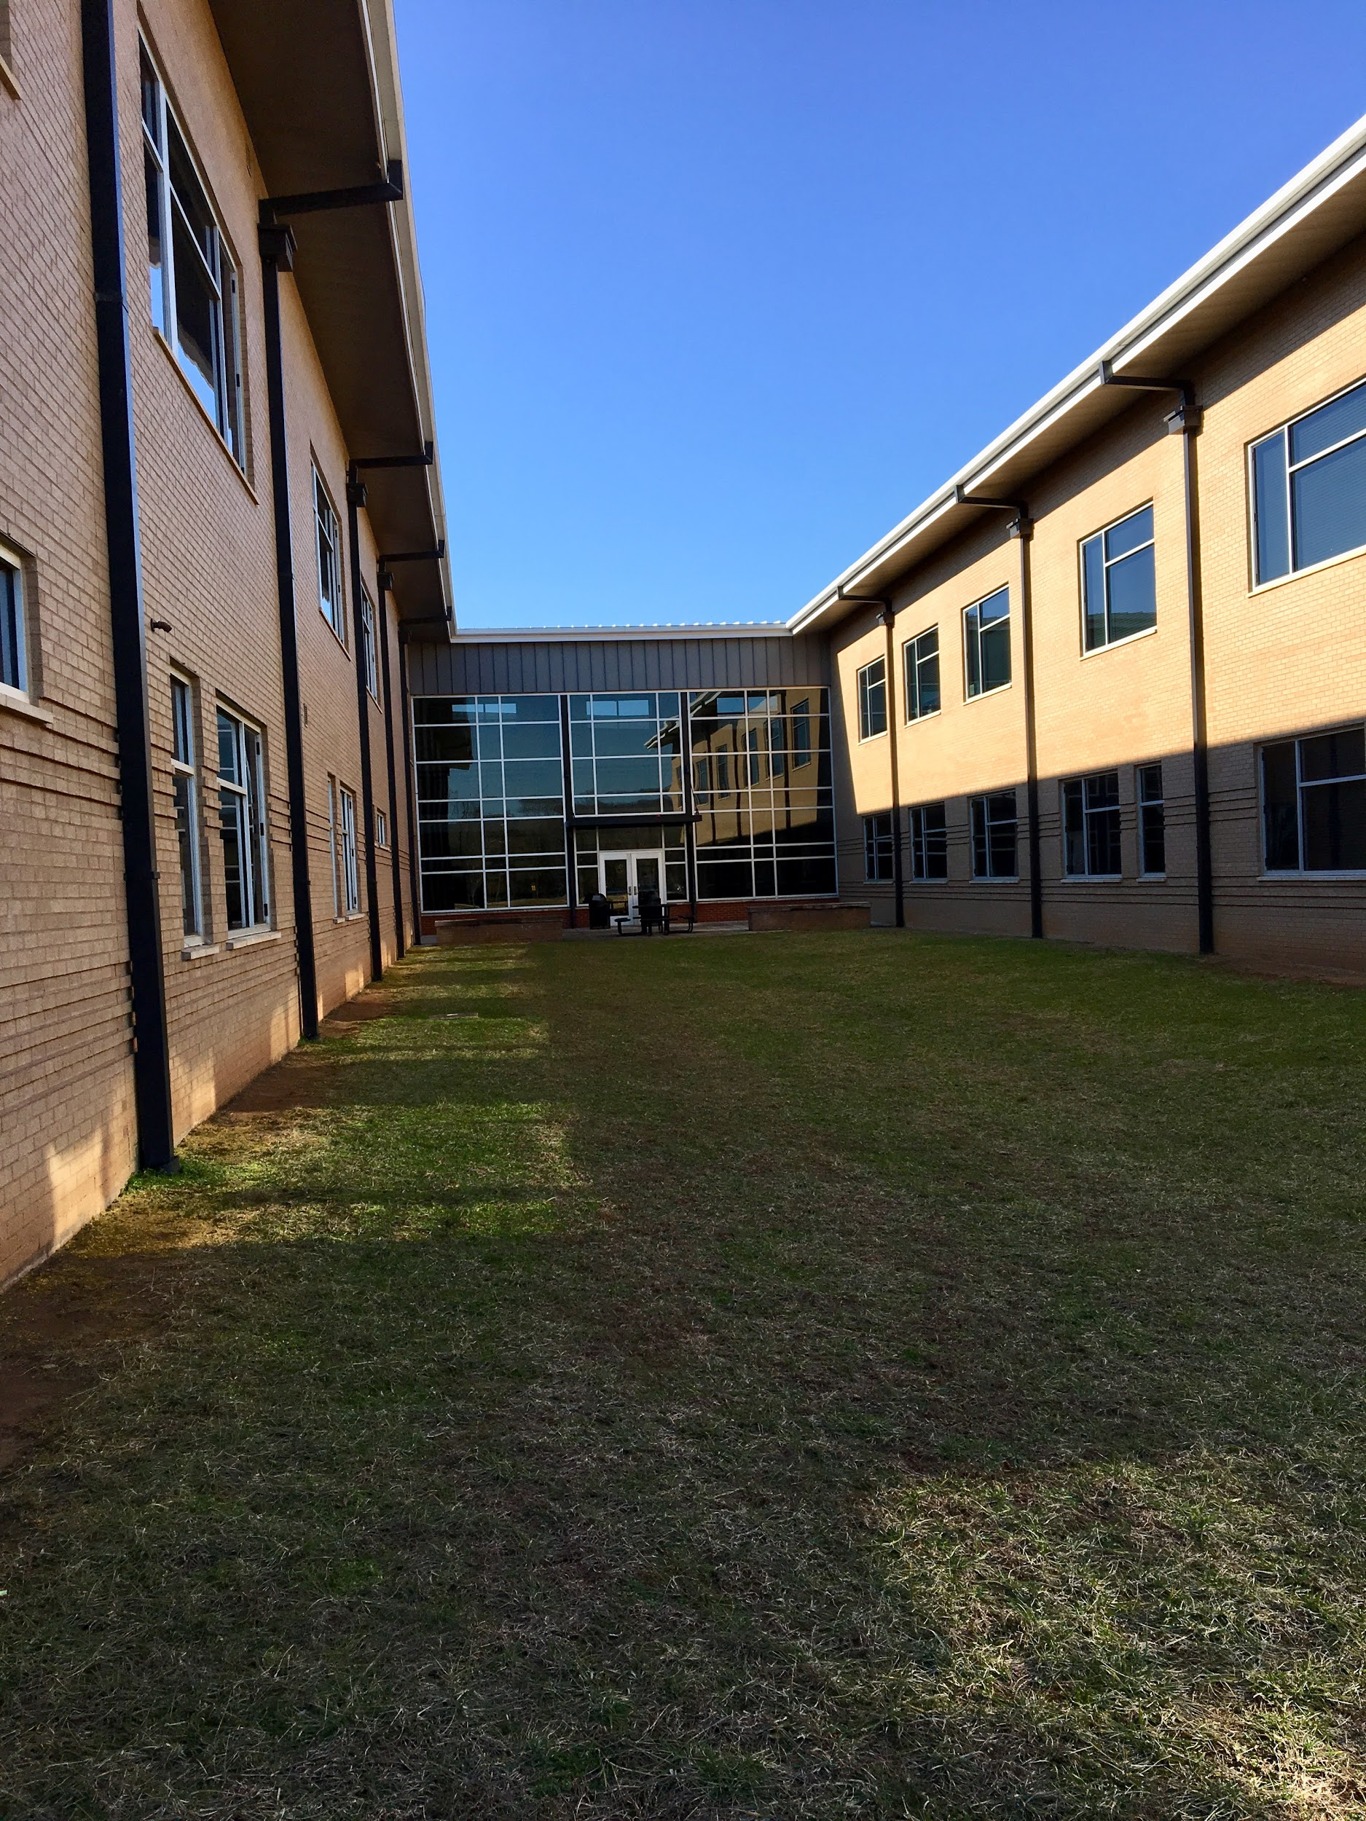
~Innovate & Create~

Budget: $1,000-$2,000

Design Deadline: Friday, March 2nd

Students of any grade level may work individually or in groups.

Students will apply a design process to create a model for an outdoor classroom for Hixson Middle School.
Students’ designs should meet the following criteria:
- Seating capacity for up to 35 students
- A space that facilitates learning
- A creative and aesthetically pleasing design

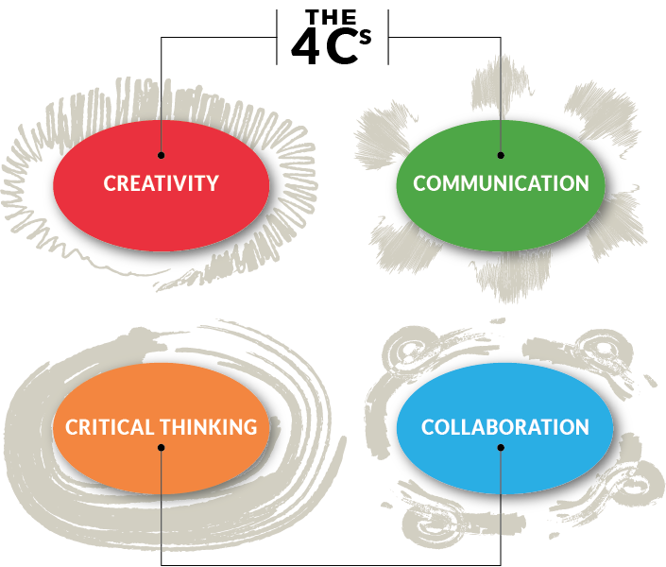
Students may create a prototype from simple materials (cardboard, paper, glue, etc.) or create a 3-D rendering using software. Please turn in projects to Mrs. Carrie Bishop. Students will receive authentic feedback on their designs from executives at Shaw Industries and educators from Hixson Middle School. The final Outdoor Classroom design will be a compilation of selected parts from several students’ designs. Students will be given credit for their contributions to the final design. Parent support and involvement is not only permitted, it is encouraged. We look forward to seeing many of the chosen design elements come to fruition on our campus this spring!
