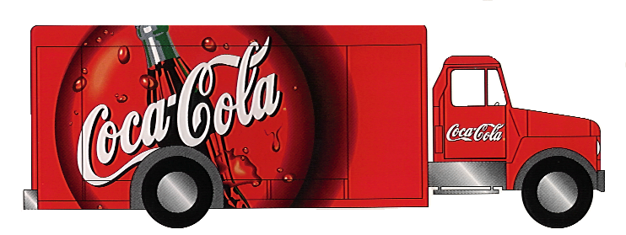

2017 Fall Coke Sale Fundraiser
Price per case = $24.00
Order turn in dates = 9/5 9/11 9/15
Schoolwide Goal = 2000 cases

Pickup Date = September 30th 9AM – 12PM

Make Checks payable to Loftis MS
(write seller’s name / HR teacher on the memo line)

There will be a $3.00 charge for
each flat that is not returned.

2017 Fall Coke Sale Fundraiser Incentives
Kickoff Date: Sept. 1
First Turn-in Date: Sept. 5
Second Turn-in Date: Sept. 11
Final Turn-in Date: Sept. 15
Individual Prizes
1 case = * Sell one case by the 1st turn-in date (9/5) and receive a dress down day on the 1st turn-in date (9/5).

3 cases = For every 3 cases sold you get an additional dress down day pass + your name is entered in a drawing for a $50 gift card

Top Seller = Each top seller from each grade level will receive lunch with Mr. Eller

Top Seller Overall = Will receive $100 gift card

HRs with 100% participation = Coke Rewards Party (pizza/Coke)
Dress down for 1 week

