Red Bank Earth Day T-shirts
Below are the three winning t-shirts designs that were drawn by several of our 7th grade students. Proceeds from this fundraiser will be used to create Breakout boxes for the teachers of RBMS to use in their classes with the students. If you are unsure what Breakout is check out their website, www.breakout.edu. It is a fun, engaging way to learn!
Orders will be placed on Tuesday, April 25th, 2017. Please have your order and money turned in to Kristy Fritsch (Room 7211) by this date.
Front design: RB on left chest
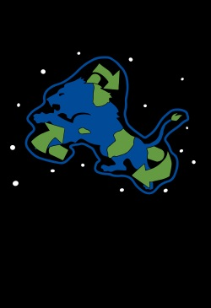
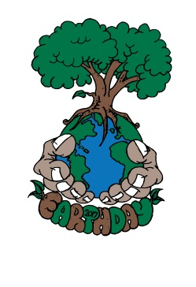
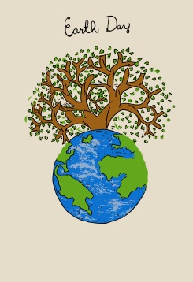
Back designs:
Hands Holding Earth Recycle RB Lion Earth & Tree on white short sleeve on black short sleeve on light tan short sleeve
Please fill out the following and return the form with payment for the shirts.
----------------------------------------------------------------------------------------
Name ___________________________________________________ Grade _______________________
Circle Design | # ordered | Cost
Hands/Earth on white $15.00 | YL __________  AS __________  AM __________  AL __________  AXL __________  AXXL add $2 __________  AXXXL add $3 __________ | $______________
Recycle RB Lion on black $15.00 | YL __________  AS __________  AM __________  AL __________  AXL __________  AXXL add $2 __________  AXXXL add $3 __________ | $______________
Earth & Tree on light tan $15.00 | YL __________  AS __________  AM __________  AL __________  AXL __________  AXXL add $2 __________  AXXXL add $3 __________ | $______________

Received: _____________________________________________________________ (sign when shirt is received)

