Sale Creek Middle High School
2018 8th Grade Summer Reading
All incoming students will need to complete one summer reading book prior to entering 8th grade. During the first two weeks of school, student understanding will be evaluated using either projects or a comprehensive assessment. The following are suggested titles, but you are not limited to only these books.
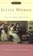Little Women by Louisa May Alcott 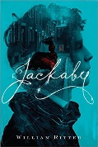Jackaby by William Ritter

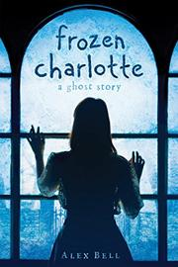Frozen Charlotte by Alex Bell 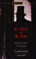The Strange Case of Dr. Jekyll and Mr. Hyde by Robert Louis Stevenson
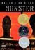Monster by Walter Dean Myers 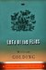Lord of the Flies by William Golding
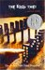The Book Thief by Markus Zusak 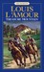Treasure Mountain
by Louis L'Amour
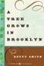A Tree Grows in Brooklyn by Betty Smith 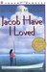Jacob Have I Loved
by Katherine Paterson
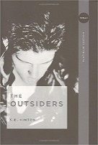The Outsiders by S.E. Hinton 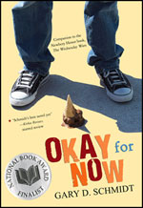Okay for Now by Gary D. Schmidt
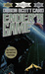Ender's Game by Orson Scott Card 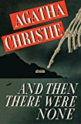And Then There Were None
by Agatha Christie
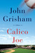Calico Joe by John Grisham 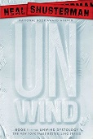Unwind by Neil Shusterman

