Sale Creek Middle High School
8th Grade Supply List
2018 – 2019
The following supplies will be collected by your child’s 1st Core Class teacher for general use:
- 1 - 4 pack of Expo dry erase markers
- 2 boxes of Kleenex
- 2 rolls of paper towels
- 2 reams of Copy paper
- 2 Clorox wipes
- 1 pack of glue sticks (3-4 sticks)
- 1 – 3 pack of clear Scotch tape
- Crayola colored pencils
- 1 pack of Post it notes
- Optional – Candy for rewards (peanut-free)

Students are to keep the following supplies on them for all core classes:
General
2 packs of #2 pencils (mechanical preferred)
2 packs of loose leaf notebook paper
1 pair of ear buds for computer use

Language Arts
1 composition book
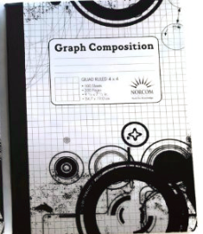
1 folder labeled “Language Arts”

Mathematics
1 graph composition notebook
1 black Expo dry erase marker
1 folder labeled “Math”
1 pack of multicolor ink pens (erasable are ok)
1 Calculator – TI 34

Science
1 composition book
1 pack of colored pencils
1 – 3 pack of clear tape

Social Studies
4 – 1 subject 70 page spiral notebooks

