Using Technology to Stay Involved at Sale Creek Middle High
salecreekmiddlehigh.com
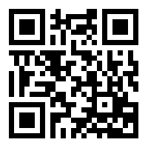
Browse to salecreekmiddlehigh.com or simply scan the QR code above to visit our school website. Be sure to save us to your favorites.

Apple iPhone or iPad
If you have an iPhone or iPad, visit the following url or scan the QR code below to download the free Powerschool App from the App Store. See the important message at the bottom of the page about setting up the app.
https://itunes.apple.com/us/app/powerschool-mobile/id973741088?mt=8

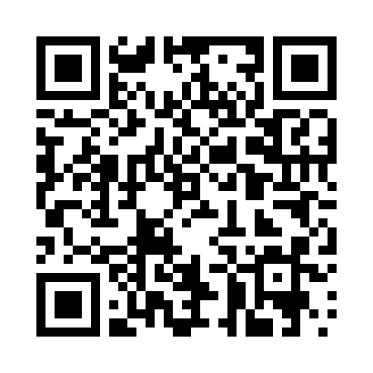

Android Device
If you have an Android phone or tablet, visit the following url or scan the QR code below to download the free Powerschool App from the Play Store. See the important message at the bottom of the page about setting up the app.
https://play.google.com/store/apps/details?id=com.powerschool.portal&hl=en

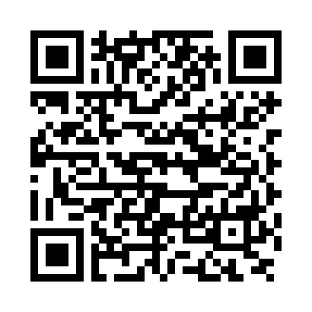

IMPORTANT:

To set up the Apple Powerschool app, do not enter a district code. It will be automatically entered for you. Click Help. Scroll down and click Search for Your District. Enter powerschool.hcde.org in the server box. You will see four stars in the district code box. Enter your student’s username and password for Powerschool. If you do not know your student’s username and password for Powerschool, contact his or her homeroom teacher or Mrs. Sena.

To set up the Android Powerschool app, do not enter a district code. It will be automatically entered for you. Click the question mark sign (?). Scroll down and click Search for Your District. Enter powerschool.hcde.org in the server box. You will now see four stars in the district code box. Enter your student’s username and password for Powerschool. If you do not know your student’s username and password for Powerschool, contact his or her homeroom teacher or Mrs. Sena.

