**Fall Picture Re-take Day**

Thursday, November 9th begins at 8:30am

**Progress Reports go home**

Friday, November 10th

**5th Grade Field Trip to Battlefield & CiCi’s Pizza**

Friday, November 10th from 8:45am–2:45pm

**Kindergarten Field Trip to Audubon Acres**

Tuesday, November 14th from 9:15am–1:30pm

**2nd Grade Field Trip to UTC Challenger Center**

Tuesday, November 14th from 8:45am–3:00pm

**Last Day of School before Thanksgiving Break**

Tuesday, November 21st

**Thanksgiving Break**

Wednesday, November 22rd - Friday November 24th

Return to school on Monday, November 27th

**Book Fair**

Monday, November 27th – Friday, December 1st

**Chili Cook-Off**

Thursday, November 30th 6:30PM @ SHES

**3rd Grade Field Trip to CCA & CiCi’s Pizza**

Friday, December 8th 10am-3pm

**Snow Hill Gift Shop**

Monday, December 11th - Friday, December 15th

**1st Grade Field Trip to Theatre Center**

Wednesday, December 13th 9:00am-1:30pm

**Chorus @ Rock City**

Thursday, December 14th 7:00pm & 7:35pm

**Holiday Parties & Half Day for Students before Winter Break**

Tuesday, December 19th

**Winter Break**

Wednesday, December 20th – Friday, January 5th

Return to school on Monday, January 8th

[](http://thesamaritancenter.net/) 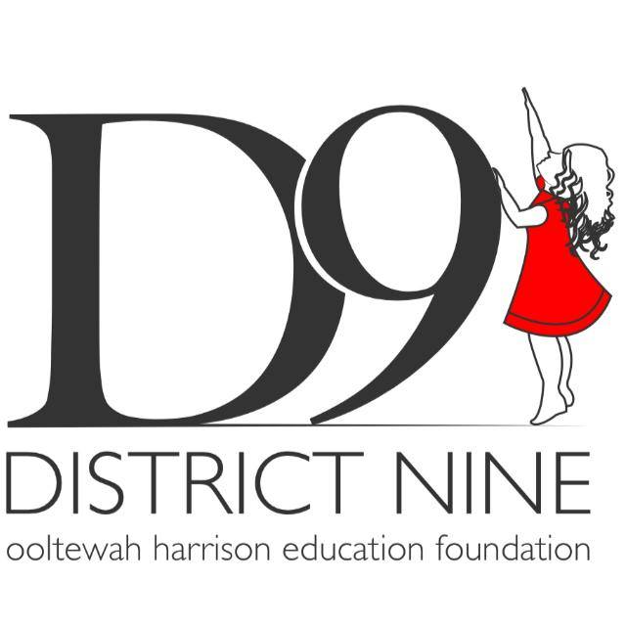

**Live Here, Give Here Food Drive**

**for the Samaritan Center**

Please help our school to be a blessing to families in need of food assistance this Holiday season. All items should not be expired, as the Samaritan Center cannot give them out to their clients.

**The class with the most food donations will receive a Pizza Hut pizza party. Please put your homeroom teacher’s name on your bag or box of non-perishable food items.** All donations need to be turned in by **Monday, November 20th**. The food barrels are located in each grade level hall.

**November** is National Epilepsy Awareness Month. 1 in 26 people in the United States will develop epilepsy at some point in their lifetime. Epilepsy is characterized by recurrent, unprovoked seizures. [Epilepsy](https://www.epilepsy.com/learn/about-epilepsy-basics) is the fourth most common neurological disease and affects people of all ages. Don’t forget to wear purple in November for Epilepsy Awareness.

**1 in 26**

**PTA Fall Festival**

**Saturday, November 4, 2017**

**11am-3pm**

**Snow Hill Elementary**

Come join Snow Hill Elementary for a day full of Food, Fun, Games, Music and Activities for all ages.

Haven’t started shopping yet? We will have many opportunities for you to get started. Come check

out our vendors, crafts, and awesome teacher baskets. You will not want to miss the live

teacher auction at 1:00pm.

Don’t worry dads…we have something for you too! 1st Annual Car Show. Come and enjoy the Antiques, Classics and Moderns.

**See you on the 4th!!!**



# Upcoming Events



SNOW HILL ELEMENTARY NEWS

We would like to invite all veterans to our flag ceremony on Friday, November 10th at 8:30am. Please join us!!!

**Flag Ceremony**

# October 31, 2017 Volume 3, Issue 1

# November

C:\Users\eddy_cindy\AppData\Local\Microsoft\Windows\Temporary Internet Files\Content.IE5\WZ1C6GM7\MC900435965[1].wmf

November- Perseverance

Pursuing worthy objectives with determination and patience while exhibiting fortitude when confronted with failure.

Just a quick reminder that supply fees are $45.00. Please send in your fees if you haven’t done so already. If you would like to send partial payments, you may do so. All supply fee money stays right here at school and helps to cover items that the county does not provide funding for us.

# School Fees