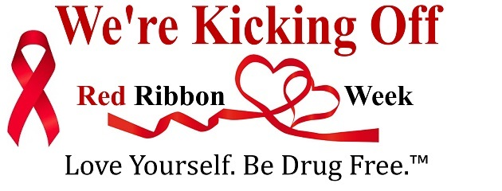

What is Red Ribbon Week?

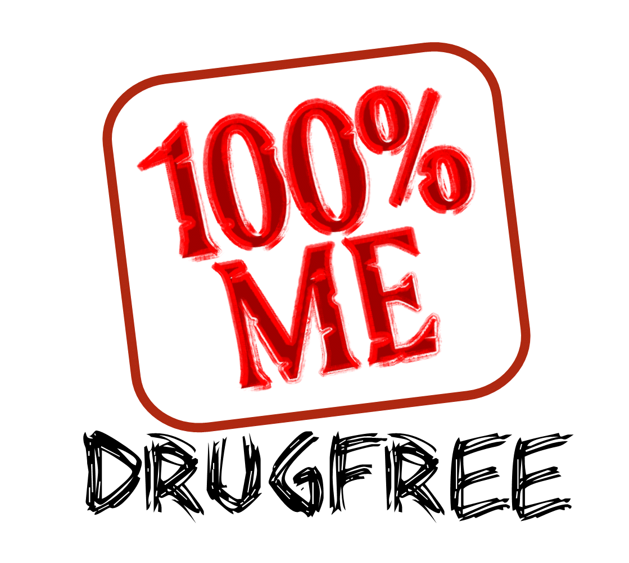
RRW is an ideal way for people and communities to unite and talk with children about the dangers of drugs while taking a visible stand against drugs.

Dress Up Days to show your Drug-Free pride!
Monday (October 23) – Be HIP, Don’t Smoke or DIP…..Dress as a Hippie and Wear Peace Signs, Tie-Dye etc. to school! (Students will get a sticker w/a Drug Free Message)

Tuesday (October 24) –The Drug Free Force is strong with us! - Wear a Star Wars shirt to school!

Wednesday (October 25) –Give Drugs the BOOT ! – Wear your boots to school! (Students will get an “I’m Too Cool to do Drugs” bracelet).

Thursday (October 26) – “Lei” Off Drugs Day! – Wear a Lei or wear a Hawaiian Shirt to school! (Each classroom will have a drawing for an “I Like Me Drug Free” Fidget Spinner).

Friday (October 27) –Team Up Against Drugs! – Come to school in your favorite team colors or jersey!
*All of the items to be given away to students have been purchased by our local
Kiwanis Club.
*Coordinated School Health will share their “Tobacco Trunk” with Ms. Beckie for Red Ribbon Week….ask your child about “Mr. Gross Mouth” and “Hairy Scary Tongue.”
Reminder…there is a “Parent Tip of the Day” on our school website provided by
Beckie Smith, School Counselor.

