How to Sign Up for Notify Me
- Go to www.mckenziehighschool.org on a chromebook or laptop.
- Click on this button…

- Fill out the following form. Make sure you click the box to receive text messages and select your service provider.
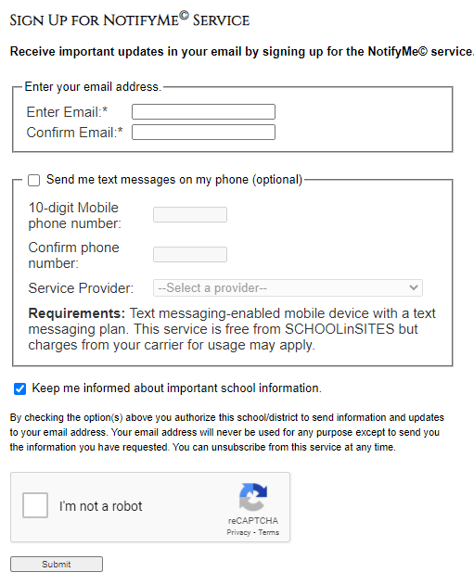
- Click submit.

- Go to your email that you listed in the form and accept the invitation to receive information from the school.

- You will now receive notifications from McKenzie High School.

