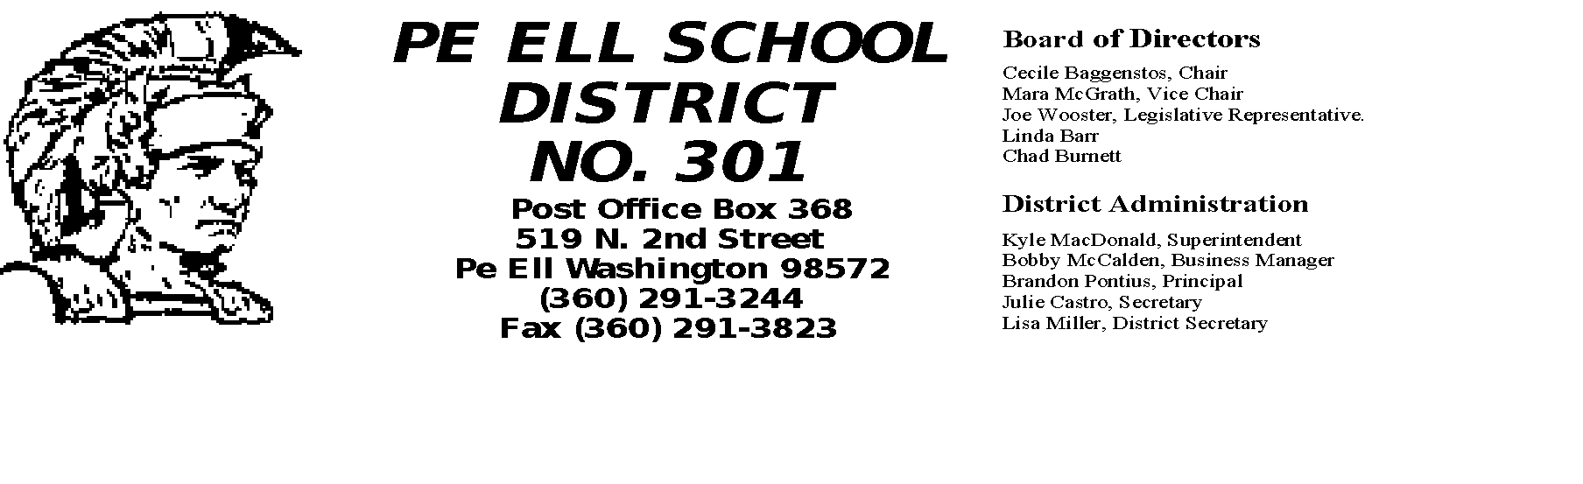Dear Families of the Pe Ell School District,

For the past two months Pe Ell School District Administration has been diligently working on plans for re-opening school for the 2020-2021 school year. Two committees composed of school staff and parents have created plans for learning/teaching strategies and logistics of operating the school – plans are attached.
Our intention is to provide face to face in person learning for all students. The staff, anxious to get back in the classroom with students, realize that student and staff safety are necessary precursors to a positive and productive learning environment. The Lewis County Health Department is setting guidelines to follow for in person school, such as health checks, face coverings, social distancing, and cohort grouping by class rank.
The district realizes some students may not be able to attend school in person. For these students there will be an alternative distance learning option created by the staff and Administration.
The District also realizes there is a possibility that the Lewis County Health Department or the State will not allow in person learning due to safety concerns. For this reason, the Staff and Administration have been creating a distance learning alternative. Some facets of distance learning that would differ from the spring of 2020: 1. Each student will have access to a school Chromebook at home if desired or required; 2. Google Classroom would be our primary Learning Management System; 3. Training on the Google Classrooms with Chromebooks will be provided for staff, students, and parents; 4. Staff will be working from their classrooms at school with all of the normal resources available during regular school hours, including email and phone.
Regardless of the circumstances governing re-opening Pe Ell School in 2020-2021, we will do our best to deliver a great education and provide a great environment for Pe Ell students. Please complete the “Returning to School Survey” at the following link: https://docs.google.com/forms/d/1fLTzMV5yZGvIBEPmv8dWtzMfc2i_DvL-4pBuKZ0luF0/edit, this survey is also located on the Pe Ell School Website: http://www.peell.k12.wa.us/.

Sincerely,

Kyle MacDonald, Superintendent

Brandon Pontius, Principal

