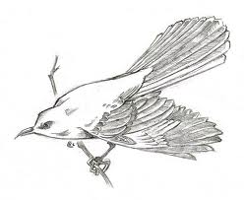
Manteno High School Library
www.manteno5.org/mhs

To Kill a Mockingbird
Historical Resources

DATABASES: Grolier – www.manteno5.org/mhs (click library, click links)
- Search by keyword, ex: Great Depression, Jim Crow, etc.
- Try “weblinks” for additional reliable resources

WEBSITES:

America in the 1930s – Great visual examples on film, in print, on display on air, timelines

http://xroads.virginia.edu/~1930s/front.html

Decades:

http://www.thepeoplehistory.com/
http://history1900s.about.com/od/timelines/tp/1930timeline.htm

Dustbowl – Summaries/pictures/stories

http://www.history.com/topics/dust-bowl
http://memory.loc.gov/ammem/afctshtml/tshome.html

Franklin D. Roosevelt – official presidential websites

https://www.whitehouse.gov/1600/presidents/franklindroosevelt
http://www.fdrlibrary.marist.edu/

Harper Lee - Biography

http://www.biography.com/people/harper-lee-9377021

Herbert Hoover – Official presidential library and museum webpage

http://hoover.archives.gov/info/faq.html

Jim Crow (PBS) - Summary of events, timelines, video stories

http://www.pbs.org/wnet/jimcrow/

Legal Definitions – common legal terms, easy to search

http://dictionary.law.com

Scottsboro Trials – University of Missouri School of Law webpage

http://law2.umkc.edu/faculty/projects/ftrials/scottsboro/scottsb.htm

Women and the 1930s - Summary

http://www.workers.org/2008/us/womens_history_month_0403/

