A comprehensive school counseling program follows the American School Counselor Association (ASCA) national model.  THE SCHOOL COUNSELING PROGRAM  PROVIDES:  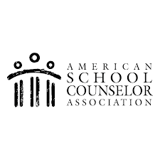  Classroom Lessons  Emotions, coping skills, conflict resolution, communication skills, respect, diversity, teamwork, friendship, & Community Circles.  Group work with students  Friendship/Social Skills/Lunch Buddies  Individual work with students  Short-term work to meet social, emotional, and behavioral goals  Crisis Intervention  Crisis prevention and safety planning  Consultation with staff/parents  Plan for student needs and provide resources and education  Referral assistance for services  Mental health, crisis support  All services strive to meet students’ academic, personal/social and career needs. |  | I am available at:  J.S. Abrams Elementary School  Monday-Friday  8:15 A.M.-3:15 P.M.  Phone:  (205) 432-3166  Email:  jadudley@bessk12.org |  | J.S. Abrams Elementary School  Dr. Armentress Robinson, Principal  Janìca Dudley, M.Ed. Professional School Counselor  Home of the Mighty Panthers  School Counseling  Program

 |  | SCHOOL COUNSELING IS FOR EVERYBODY!!!  Part of my job is to get to know each and every student in our school, so I may help them feel connected and safe while they’re with us.  Much of my work with students is confidential, which means I respect your child’s right to privacy. If there’s something I think you need to know, I will definitely contact you!! |  | 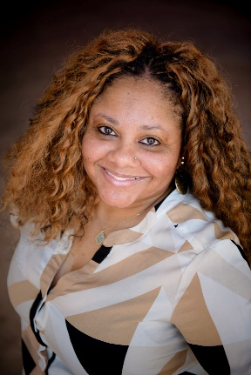
When do I see a Counselor?  When I…  Have good news  Have trouble with friends, school work, Have problems with others  Need to talk to someone  How do I see a Counselor?  My teacher asks the counselor to see me  My parents can ask the counselor to see me  I can ask my teacher if I can go to her office  Your support and cooperation can help make your child’s school years a rewarding experience. |  |  |  | Hello! My name is Janìca Dudley, and I’m your School Counselor.  As your School Counselor, I work with students, teachers, administrators, support staff, parents/guardians, and members of the community. I am an important part of a team that works to create a positive learning environment for all students reflective of our school’s core values-safety, respect, and responsibility.  I look forward to getting to know your child or continuing to help your child become a successful student and citizen!

