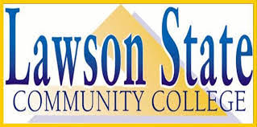

For: Bessemer HS Rising Sophomores
When: Monday, July 22, 2019
Where: Bessemer High School Library
Time: 5:00 PM – 7:00 PM
Benefits: Earn High School Credits
Earn College Credits
Qualifying Students Receive Free Tuition
Discover Career Opportunities
Meet New Friends
Requirements: 3.0 GPA
Fields of Study
General: English, Speech, Psychology, Art
Music, Microcomputer & Other Courses
Career Tech: Nursing Assistant Automotive,
HVAC, Welding, Introduction to
Computers & Other Courses

Dual Enrollment applications can be download at bessk12.org or http://lanier.bcss.schoolinsites.com/

A partnership between Lawson State Community College and Bessemer City School System.

