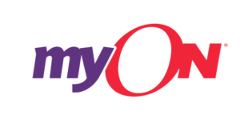

Dear Families,
With access to myON, your students have more than 7,000 digital books in their hands every day and at any moment. myON is a digital library complete with all of the titles from Capstone as well as many exciting third party publishers. Students and parents can access myON in school, at home or anywhere across the community with WiFi on a web-based device.

Research shows that when students have the opportunity to choose books at their level and within their interests, they will be more engaged in reading. Families should read together whenever they have the opportunity.

The digital books on myON’s platform have optional scaffolds, including audio, text highlighting and an embedded dictionary, to support students at every level. myON has books from every genre to engage even the most reluctant readers: fiction, biographies, scientific texts, graphic novels and more. All of the books create a magnificent learning experience for students.

To read on myON:
1. Go to www.myON.com/login (it is best to use Chrome or Safari browsers)
2. School Name: Charles Hard Elementary
3. Username: student first initial and last name with 4 numbers _______________________________
4. Password: hard65

