Grove Hill After School Adventure  21st Century Community Learning Center  A Safe Place for Fun Enriching, Academic, and Physical Explorations!!!  Grant Director  Niquitha Merida  Lead Teacher  Clara McMillian  Tammy Witherspoon  4H-Enrichment Coordinators  Cheryl Horton  Tracey R. Williams  Highly Qualified Teachers  Andrea Carpenter Wendy Chaney  Rochandolia Burroughs Melanie Watters  Anita Washington  Adult Teacher Assistant  Lelia Pugh  Location  Grove Hill Elementary School  450 West Cobb Street  Grove Hill, Alabama 36451  251-275-3423 |  | Larry Bagley, Superintendent  Debra Dennis, Principal - CCHS  Kathy Spidle, Principal – GHES  Carolyn Taite – WHMS  Niquitha Merida, Grant Director/Assistant Principal- GHES  21st Century  Community Learning Center  Clarke County Public School  Parent/ Student Handbook  Clarke County High  Grove Hill Elementary  Wilson Hall Middle  “Children Are Our Business!”  21st Century Community Learning Center  Grove Hill  A S A  After School Adventure
PARENTAL INPUT  The After School Program is designed to meet the needs of the school community. Several opportunities for discussion and program evaluation will be formally provided throughout the year. Other parental comments/concerns are encouraged.  VOLUNTEERING  Please volunteer to share your talents! If you have any talents or skills, please let the Site Director know. We are always excited to introduce new skills and culture diversities. We will be more than happy to set up a time for you to demonstrate and share with our students. |  | Clarke County Board of Education  P.O. Box 936  Grove Hill, AL 36451  Dear Parents,  The Clarke County School System will offer a 21st Community Learning Center Program for your child during the 2015-2016 school year for students at Grove Hill Elementary, Wilson Hall Middle and Clarke County High School. The information in this handbook has been designed to help you understand the program.  This program is designed to provide our students a safe and educational atmosphere during the after school hours. If you have any comments or questions concerning this program, feel free to contact your program director. Your input is a vital part of the success of this program.  We are happy to have your child enrolled in the After School Program. We feel that your child will benefit from his or her experiences in this program.  Sincerely,  Director and Staff of the Grove Hill After School Adventure
PURPOSE OF THE  GROVE HILL AFTER SCHOOL ADVENTURE  COMMUNITY LEARNING CENTER  Grove Hill’s After School Adventure 21st Century Community Learning Center (GHASA CLC) is offered as a service to any child in grades Preschool- 9th Grade. Our main objective is to enhance each child's physical, social, emotional and intellectual well-being. Our primary goals for this program are as follows:  - To provide students with a quality, affordable, educational, learning experience during the afternoon hours  - To provide a proper environment for after-school study, enrichment and socialization  - To better utilize our school facilities for the benefit of the community we serve  - To provide certified educational staff to assist in academic goals  - To provide a safe and enriching atmosphere to all students during the after-school hours  - To assist our families with family literacy and strengthen parental involvement  - To provide students with high quality enrichments that will stimulate inquiry learning henceforth, producing measurable academic progress in all content areas  - To stimulate critical thinkers by focusing on Science, Technology, Engineering, and Mathematics (STEM) has become a focal point for improving students academically, our staff is committed to incorporate these key focal points in every lesson and unit  - To offer remediation, enrichment, tutoring, physical fitness, technology, and enhancement in the arts  - To keep our students moving and physically fit; therefore, we promote thirty minutes or more of non-stop mobility |  | DISCIPLINE  Our code of conduct will follow the same regulations established for the regular school day. Failure to comply with these rules will make it necessary for us to do the following:  - Discuss the problem with the child and help to determine causes and ways to resolve it.  - Time out from activities  - Discipline note sent home to inform parents of behavior. (3 forms can result in dismissal from our program. An example of the Discipline form is below.)  The safety of our students is our main priority. Therefore, it is imperative that all students follow directions as given by the teacher. If a child’s behavior consistently disrupts the program, physically or emotionally harms others, and otherwise conflicts with program rules and guidelines, a conference with parents will be required. In the event that the problem persists after all reasonable attempts have been made, the child may be dismissed from the program.  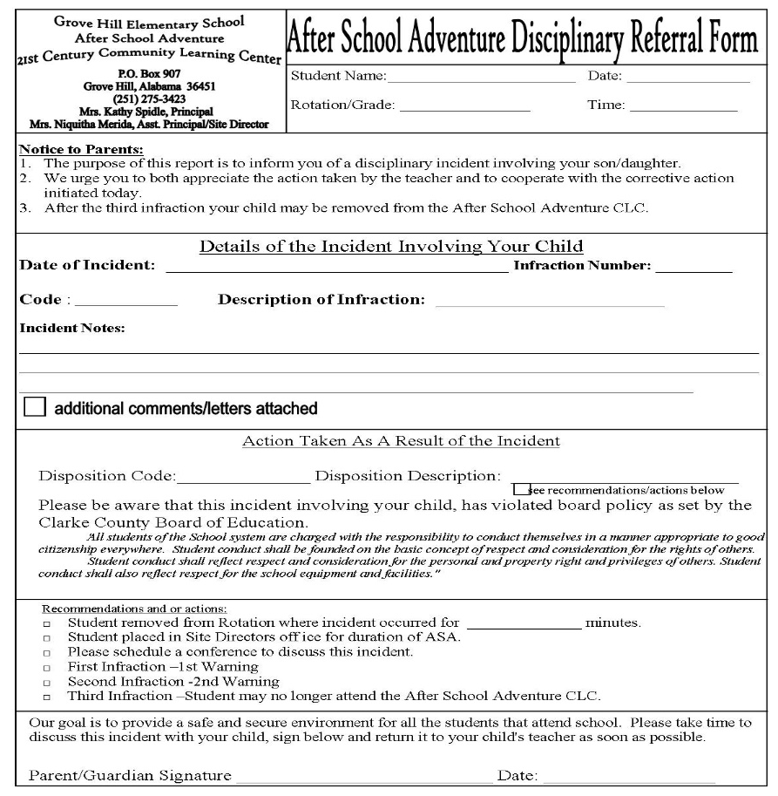
Tuition  All tuition is due by the 15th of each month. If your child is a drop-in student, you will pay on the days he/she attends. Tuition must be paid on the day your child attends. Tuition must be paid in order for your child to attend. This insures your child’s place in the program and helps provide supplies as well as highly qualified staff. For this reason, absences will not be credited or refunded.  Tuition will be accepted in the form of cash, check, or money order. All payments should be placed in a sealed envelope with your child’s name, homeroom teacher’s name, the amount you are paying and the name of the month for which you are paying.  Should you write a check and it is returned, we expect you to pick up the returned check within two weeks of being notified. Should we receive a returned check; the center will no longer accept checks for your child’s tuition. ONLY cash or money order will be accepted.  If there is an anticipated problem, please notify the program director. We will work with you!  Tuition is as followed:  $20.00 Registration Fee for each child  Tuition:  1 Child-$30.00 per month  2 Children-$40.00 per month  3 Children-$50.00 per month  4 Children-$60.00 per month |  | ENROLLMENT  Before a child attends our after-school program, enrollment must be completed. Only a parent or legal guardian can register a student for the ASA CLC. It is the responsibility of the parent or guardian to complete all forms accurately. Notification of any changes in pertinent information such as phone numbers, addresses, guardianship, and medical information must be made in writing to the school supervisor. Changes will not be made based on a verbal message by a child. ANY and ALL changes must be made in writing. Enrollment is not complete until all registration fees are paid and a completed application is on file.  CALENDAR OF OPERATION  The ASA CLC Program will operate on the same calendar as Grove Hill Elementary School. The program will be closed on those days recognized as school holidays. The hours of operation will be 3:00 p.m. until 5:30 p.m. Monday through Friday, except on designated school holidays and partial workdays as determined by the superintendent. In those rare situations where regular school is closed or cancelled due to weather conditions, the After-School Program will be cancelled. In the event the area is under weather advisement for after school hours, the center will close. (see severe weather section) Please have alternate arrangements for your child to get home.  ACTIVITIES  The After School Program offers a variety of opportunities for students during the after-school hours. A typical afternoon includes: a healthy snack, homework assistance, tutoring, physical and enrichment activities (ex... computer skills, cooking classes, rhythmic dance). STEM (Science, Technology, Engineering and Math) has become an important part of our activities. The enrichment coordinators will incorporate STEM daily. We also will call on community and civic leaders to help expand interest and experience in our program. Our goal is to have as much community and parental support as possible.
ARRIVAL/DEPARTURE  Children will departure from their classrooms to the ASA CLC program. Parents or only those specified on the registration form will be allowed to come into the school to pick up students. Identification will be required when new or unknown adults pick up students. You must pick up your child before 5:30 each day. An adult must come into the lobby to sign out a student. All students will remain in the building until they have been signed out and ready to leave. We do not want any of our students in harm’s way, for other parents will be driving up to pick up their child as well. This regulation is mandatory in the federal grant program for safety reasons and will be strictly enforced. There will be no exceptions to the rule. Late pickups will be assessed $1.00 for each minute late after 5:15 p.m. (ex...2 min. = $2.00, 7 min = $7.00). This will be added to your tuition. Please be on time. Repeated late pickups will result in your child being dropped from the program.  ATTENDANCE  Attendance is very important. Your child is expected to be at ASA CLC on the days he/she is registered. For example, if your child is registered on Monday, Wednesday and Thursday, he/she will be on roll for those three days only. Excessive absences can result in termination from the program. If your child is a drop-in student, it is your responsibility to send a note explaining in detail what days your child will be staying at GHASA CLC. No drop-in students will be allowed to remain for GHASA activities without a note. We are fortunate to have so many of our boys and girls interested in the program that a waiting list has been formed. If your child is not in attendance regularly, he or she may be replaced by someone on the waiting list.  TERMINATION OF ATTENDANCE  Please give a week’s notice if your child will no longer be attending the After-School Program. All accounts should be paid in full. |  | SICKNESS  Children who are sick (throwing up or with fever) cannot be allowed to attend the After-School Program until deemed well and ready to return to school. Parents will be called and informed about their child’s condition. Children who are not feeling well will be allowed to lie down until they can be picked up. No medication will be given by Grove Hill After School Adventure 21st CCLC.  SEVERE WEATHER  Students in the GHASA Program will follow the same inclement weather guidelines that are followed during the regular school day. They will have practice drills for fire and severe weather on a regular basis. If an alert is issued before school is dismissed, your child will remain with his/her regular classroom teacher until the alert is cancelled. If a warning alert is issued during the ASA Program, your child will be immediately moved to a safe designated area within our building. You will be called and advised where to pick him/her up. If we are informed by the local EMA of bad weather approaching before school is dismissed, we will either cancel our program or shorten our day. Parents will be notified and asked to come as soon as possible. If for some reason you are unable to leave work early, we ask that you have an alternate way for your child to go home. Rarely will this happen; however, we have families to go home to and traveling in bad weather can be risky. This policy has been put into place for your safety as well as ours.  COMMUNICATION  It is a goal of the ASA program to keep you informed; therefore, newsletters and calendars will be sent home periodically. You will be notified in advance of special activities occurring during ASA. Calendars and notices will be placed on the sign-out table. Parents are encouraged to pick up all newsletters and notifications each time they are made available.

