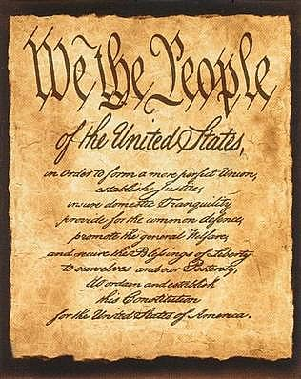

We the People of the United States

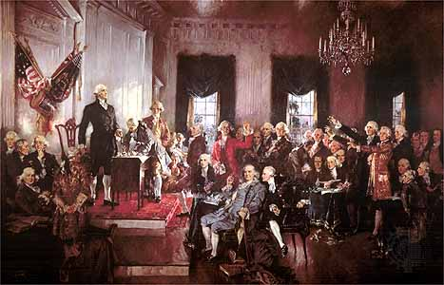

Mr. Lambert

Civics

Period

Preamble and Amendment Illustration Book

Table of Contents

Page 2 In order to Form a More Perfect Union

Page 3 Establish Justice

Page 4 Insure Domestic Tranquility

Page 5 Provide for the Common Defense

Page 6 Promote the General Welfare

Page 7 Secure the Blessings of Liberty to ourselves and our Posterity

Page 8 Amendment 1

Page 9 Amendment 2

Page 10 Amendment 3

Page 11 Amendment 4

Page 12 Amendment 5

Page 13 Amendment 6

Page 14 Amendment 7

Page 15 Amendment 8

Page 16 Amendment 9

Page 17 Amendment 10

Page 18 Amendment 11

Page 19 Amendment 12

Page 20 Amendment 13

Page 21 Amendment 14

Page 22 Amendment 15

Page 23 Amendment 16

Page 24 Amendment 17

Page 25 Amendment 18

Page 26 Amendment 19

Page 27 Amendment 20

Page 28 Amendment 21

Page 29 Amendment 22

Page 30 Amendment 23

Page 31 Amendment 24

Page 32 Amendment 25

Page 33 Amendment 26

Page 34 Amendment 27

In order to form a more perfect union

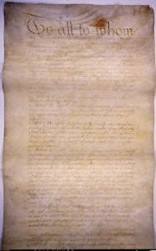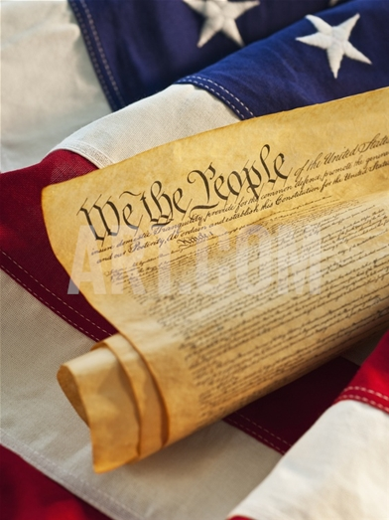

The Founding fathers have spoken!

The new Constitution avoided the worst difficulties of the Articles of Confederation.

Establish Justice

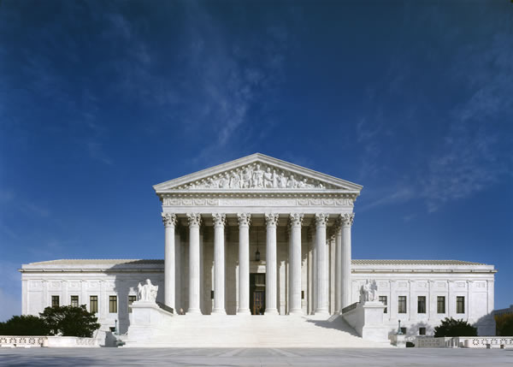

The Constitution created the court system.

This goal was made to make laws and establish a fair court system.

Insure Domestic Tranquility



The federal and state governments share the power of maintain peace.

This goal is to make sure that the Constitution maintains law and order at home.

Provide for the common defense



The Constitution authorized Congress to create an army and a navy.

This foal was created so that the government could protect the nation against its enemies.

Promote the general welfare



Over time, the U.S. government has given all citizens the right to vote.

This goal was established to ensure the well being of the entire population.

Secure the blessings of liberty to ourselves and our posterity



The Bill of Rights

This goal was to safeguard people’s personal freedom.

Amendment 1



Freedom of Religion

Freedom of Speech

Freedom of the Press

The right to assemble peacefully

The right to petition the government

The First Amendment give Americans their basic rights.

Amendment 2



Right to bear Arms!

The Second Amendment gives the American people the right to have basic weapons.

Amendment 3



Housing of Soldiers!

The Third Amendment protects Americans from having to quarter soldiers.

Amendment 4



Search and Seizure

Amendment Four preserves our freedoms. It provides the American people the right to a warrant being issued.

Amendment 5

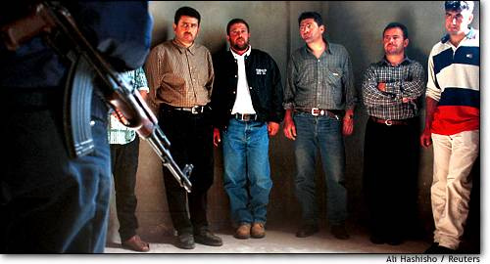

Rights in Criminal Cases

The Fifth Amendment protects the American people from double jeopardy, from incriminating themselves by pleading the fifth, and so the government cannot take your land unless it pays. **(eminent domain)**

Amendment 6



Right to a fair trial

The Sixth Amendment gives the American people the right to a speedy trial by impartial jury—meaning not favoring either side. Also, your rights must be explained to you, and you are allowed a lawyer if you cannot afford one.

Amendment 7

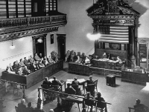

Rights in Civil Cases

Amendment Seven allows a jury trial in Civil Cases when the amount disputed is more than $20.

Amendment 8

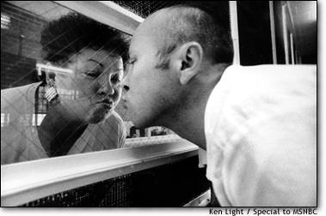

Bail, Fines, and punishment

Amendment Eight protects against cruel and unusual punishment and excessive bail.

Amendment 9



Other rights not mentioned

The Ninth Amendment protects Americans with rights that are not mentioned in the Constitution. Some of these rights include the right to marry, to have children, to own a home, and so on.

Amendment 10

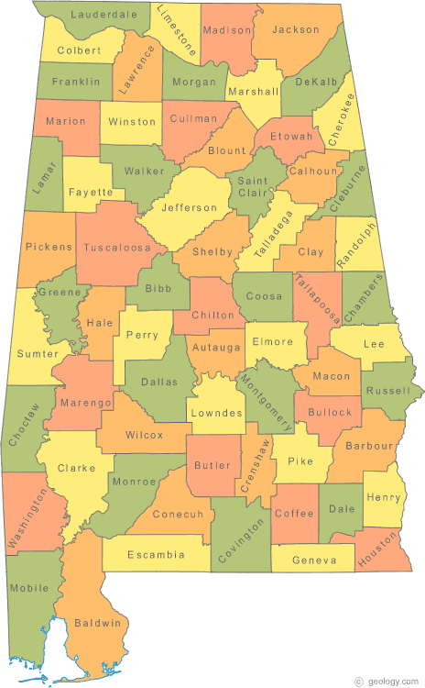

Powers reserved to the States

The Tenth Amendment gives certain rights to the states that the U.S. Constitution does not give to the federal government. Some of these rights include marriage laws, setting up of schools, and creating city and county governments.

Amendment 11

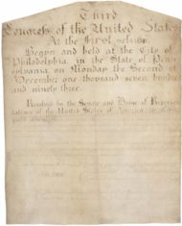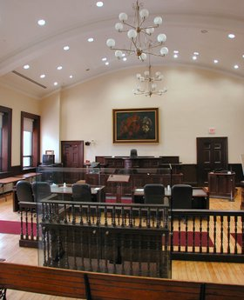

Lawsuits against States

The Eleventh Amendment clarifies judicial power over foreign nationals, and limits ability of citizens to sue states in federal courts and under federal law.

Amendment 12

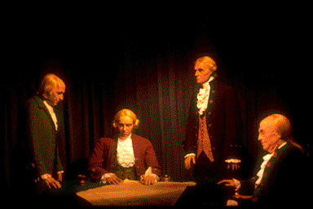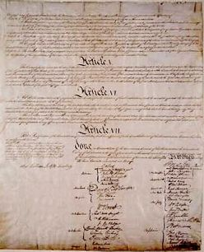

Presidential Elections

The Twelfth Amendment changes the method of presidential elections so that members of the Electoral College cast separate ballots for president and vice president.

Amendment 13

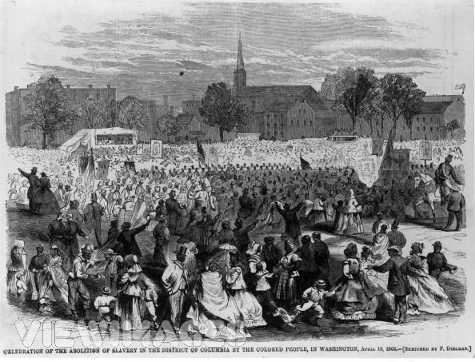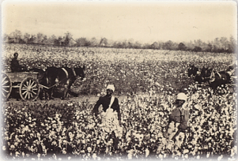

End of Slavery

The Thirteenth Amendment abolishes slavery and grants Congress power to enforce abolition.

Amendment 14

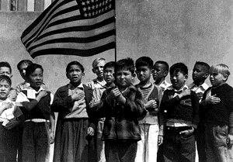

Due Process and rights of Citizens

The Fourteenth Amendment defines United States citizenship; prohibits *states* from abridging citizens' privileges or immunities and right to due process and the equal protection of the law; repeals the three-fifths compromise.

Amendment 15

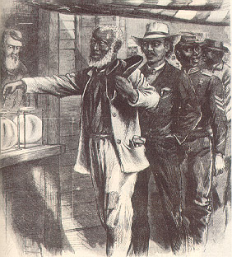

Right of blacks to Vote

The Fifteenth Amendment prohibits the federal government and the states from using a citizen's race, color, or previous status as a slave as a qualification for voting.

Amendment 16

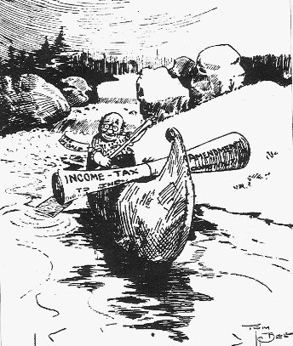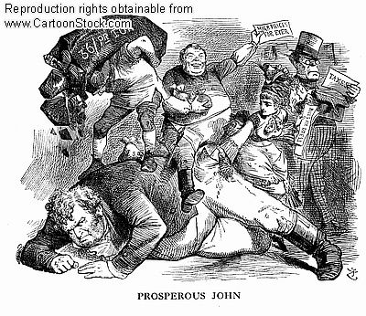

Income Tax

Amendment Sixteen authorizes unapportioned federal taxes on income.

Amendment 17

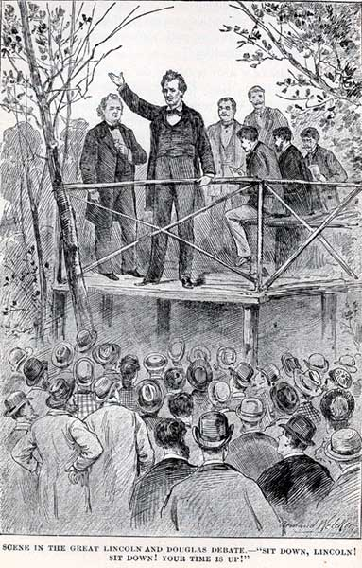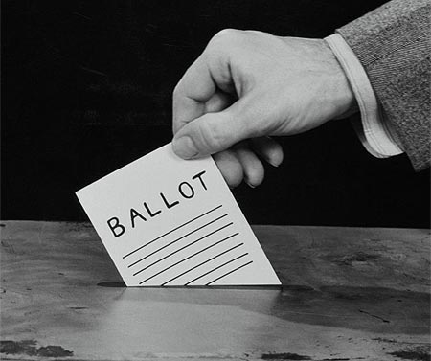

Elections of Senators

Amendment Seventeen establishes the direct election of senators.

Amendment 18

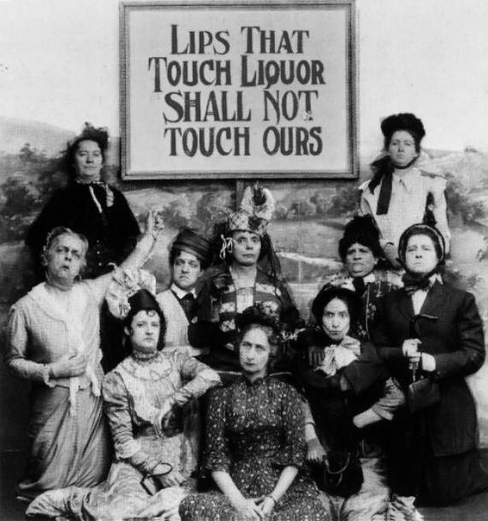

Prohibition of Liquor

The Eighteenth Amendment prohibited the manufacturing, importing, and exporting of beverage alcohol. It was repealed by the Twenty-First Amendment.

Amendment 19

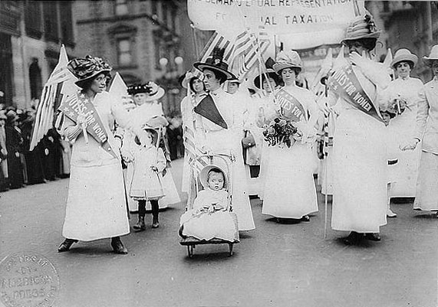

Right of women to vote

The Nineteenth Amendment prohibits the federal government and the states from using a citizen's sex as a qualification for voting.

Amendment 20



Beginning and Ending dates for Elected Officials

The Twentieth Amendment changes details of congressional and presidential terms and of presidential succession.

Amendment 21



Repeal of Prohibition

The Twentieth-First Amendment repeals the Eighteenth Amendment but permits states to retain prohibition and ban the importation of alcohol.

Amendment 22



President limited to two terms

Amendment Twenty-two limits the president to two terms.

Amendment 23



Voting in Washington D.C.

Amendment 23 grants presidential electors to the District of Columbia.

Amendment 24

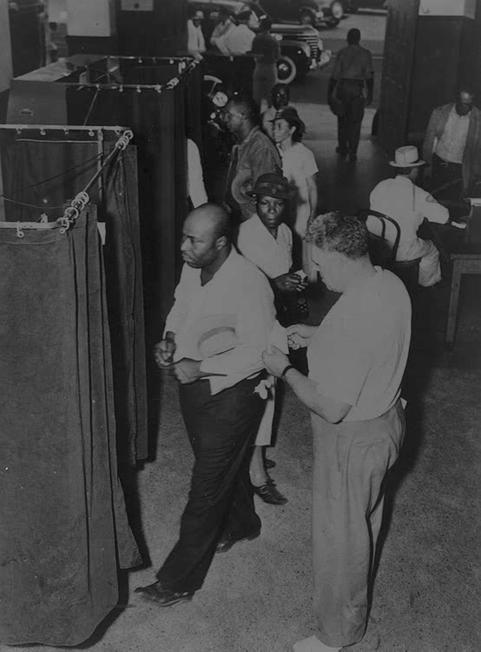

End to Poll taxes

Amendment Twenty-Four prohibits the federal government and the states from requiring the payment of a tax as a qualification for voting for federal officials.

Amendment 25

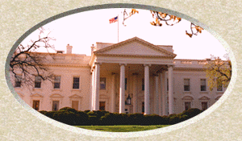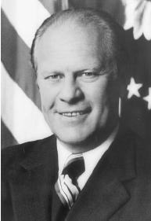

Presidential Succession

The Twenty0Fifth Amendment changes the details of presidential succession, provides for temporary removal of president, and provides for replacement of the vice president.

Amendment 26

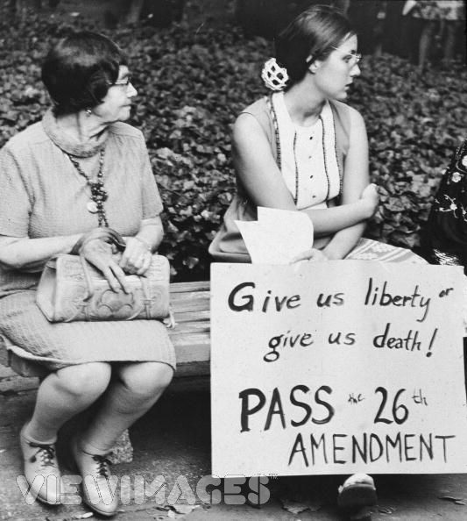

Voting age at 18

The Twenty-Sixth Amendment prohibits the federal government and the states from using an age greater than 18 as a qualification to vote.

Amendment 27

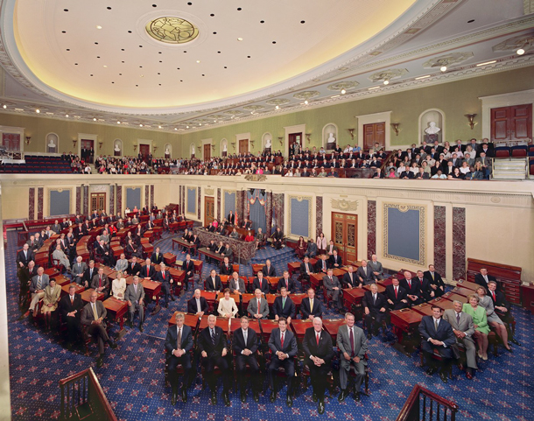

Congressional Pay

The Twenty-Seventh Amendment limits congressional pay raises.