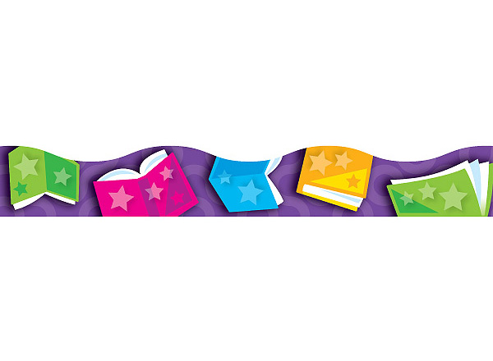


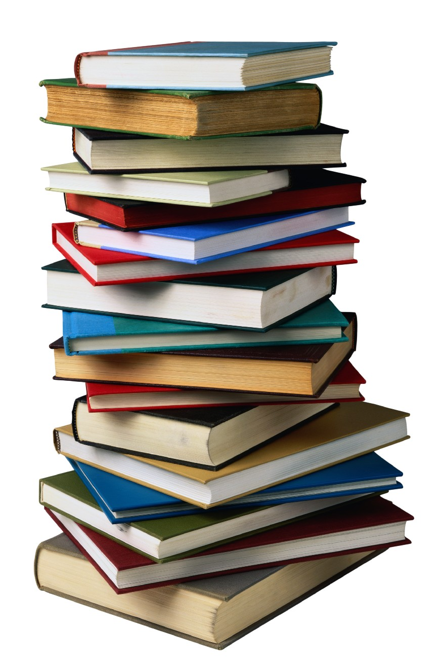
Library News
Word from
Library Media Specialist

My name is Heather Pendley, and I am the Library Media Specialist for New Bethel Elementary. This is my first year at New Bethel and my first year as a Library Media Specialist. This year has flown by! I have had so much fun working with the students and staff this year. I wanted to give everyone a newsletter to end out our year here in the library. This newsletter includes some information about what has happened this year. Thank you so much for making my first year a successful one!

Heather Pendley
Library Media Specialist
New Bethel Elementary School
New Items in the Library
This year we have been able to add many new things to our library. We have added 435 new books with 49 of those being eBooks. We have Cubelets and Little Bits to help us explore robotics in the upper grades. We have updated our computer lab with Chromeboxes. We have also added two tabletop bookcases, one mobile bookcase, and two Chromebooks. ☺
Funding for the Library

We had two fundraisers in the library this year. One was our Book Fair. I am excited to say that we raised $2691.95. We earned $1505.58 from the sales. The second fundraiser was the Reading for Education fundraiser with the address booklets. We raised $396.50. Lastly, at the beginning of the school year the Board of Education gave all the libraries extra money and we received $2910.00 from them. All I have to say is THANK YOU to everyone that has helped this year! You made it possible to get all of the new books and technology our library has. THANK YOU for your support!

Coding & Computer Time
This year we have spent a lot of time learning about code. In December kindergarten through sixth grade participated in the Hour of Code. If you would like to continue the fun this summer at home, you can go to www.code.org. There you can learn coding along with your child. They especially like Lightbot. ☺
For younger students, www.starfall.com is a great website. To practice typing skills, www.typingclub.com will help! Continue the fun this summer!

Accelerated Reader (AR)

We have had a great year with AR. Many students worked hard and participated. The last day for AR points will be May 12th. After this, I will look to see who has met their class goal, and they will receive a certificate. The student with the most points in his/her class will receive a trophy. The top student in the school will also receive a trophy. This is for 1st-6th grade.

Keep Reading!
There are several public libraries in our area that have summer programs.

Helen Keller Public Library
(256) 383-7065
Muscle Shoals Public Library
(256) 386-9212
Florence-Lauderdale Public Library
(256) 764-6564

Check these libraries out! Keep reading & don’t forget to be a STAR reader this summer.
More details to come about our summer reading challenge.

